**📖 About Me**

I am an aspiring **Technical Trainer and IT professional** with experience in **Microsoft Azure, DevOps, AI, and Data Analytics**, currently pursuing an MSc in Management with Data Analytics at BPP University. I have delivered multiple workshops, hackathons, and training sessions in collaboration with Microsoft, Reskilll, and academic institutions.

This portfolio showcases selected highlights of my work, including training events, technical projects, and community engagement activities, demonstrating my ability to deliver impactful learning experiences.

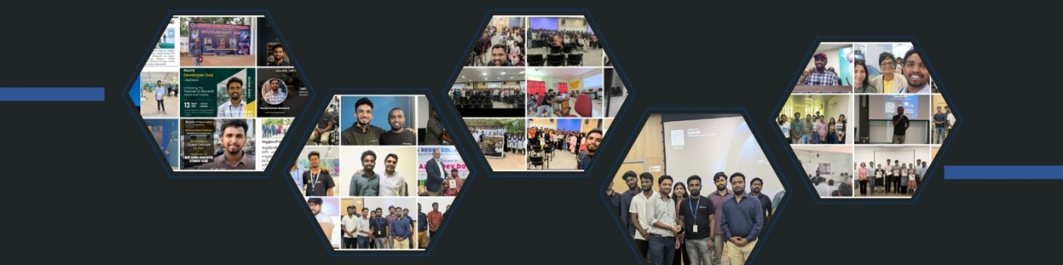

**Introduction**

Hello, my name is **Mukkera Pavan Kumar**, and I am a technology-focused professional with experience across technical training, cloud computing, community leadership, and programme delivery. Over the last three years, I have worked with students, professionals, universities, and organisations to create impactful learning experiences, support digital adoption, and deliver hands-on technical sessions.

My background includes leading large-scale **Azure, AI, and DevOps workshops** as a community lead, organising events and bootcamps, designing structured learning content, and supporting teams with cloud, automation, and digital tools. I have also contributed to business process improvement, documentation, and technical operations through my roles in industry and community ecosystems.

Currently, I am pursuing an **MSc in Management with Data Analytics** at BPP University, which strengthens my ability to combine technical knowledge with strategic, analytical, and operational thinking.  
**I am currently in my placement year, which allows me to work full-time and take on professional responsibilities without any restrictions.**

This portfolio highlights my journey—technical projects, community programmes, training engagements, events, collaborations, and leadership experiences. I am passionate about helping people learn, enabling organisations to adopt new technologies, and creating meaningful community impact through innovation and skills development.

I am always excited to contribute, learn, and grow within dynamic teams that value problem-solving, creativity, and continuous improvement.

**Event / Training Highlight – 1**

📅 **Date:** 6th–7th October 2023  
📍 **Location:** CMR College of Engineering & Technology, Hyderabad  
🏢 **Organizer/Partner:** Reskilll & Azure Developer Community  
🎤 **Role:** Reskill Inspirer – Hyderabad Region / Event Lead

**Event Name**

*Azure Developer Community Event – CMR College of Engineering & Technology*

**Description**

I co-led and organized a **two-day Azure-focused technical event** at CMR College of Engineering and Technology, bringing together students, developers, and industry experts. The event featured Microsoft employees **Adithya Saladi** and **Krutam Hathi** as keynote speakers, who shared valuable insights into **Azure technologies, cloud innovation, and career growth in tech**.

* Audience: 200+ students and faculty
* Duration: 2 days
* Key Topics: Azure cloud services, developer practices, career pathways in Microsoft ecosystem
* My Contribution: Coordinated event logistics, managed registrations, engaged with speakers, and inspired students as Reskill Inspirer for Hyderabad

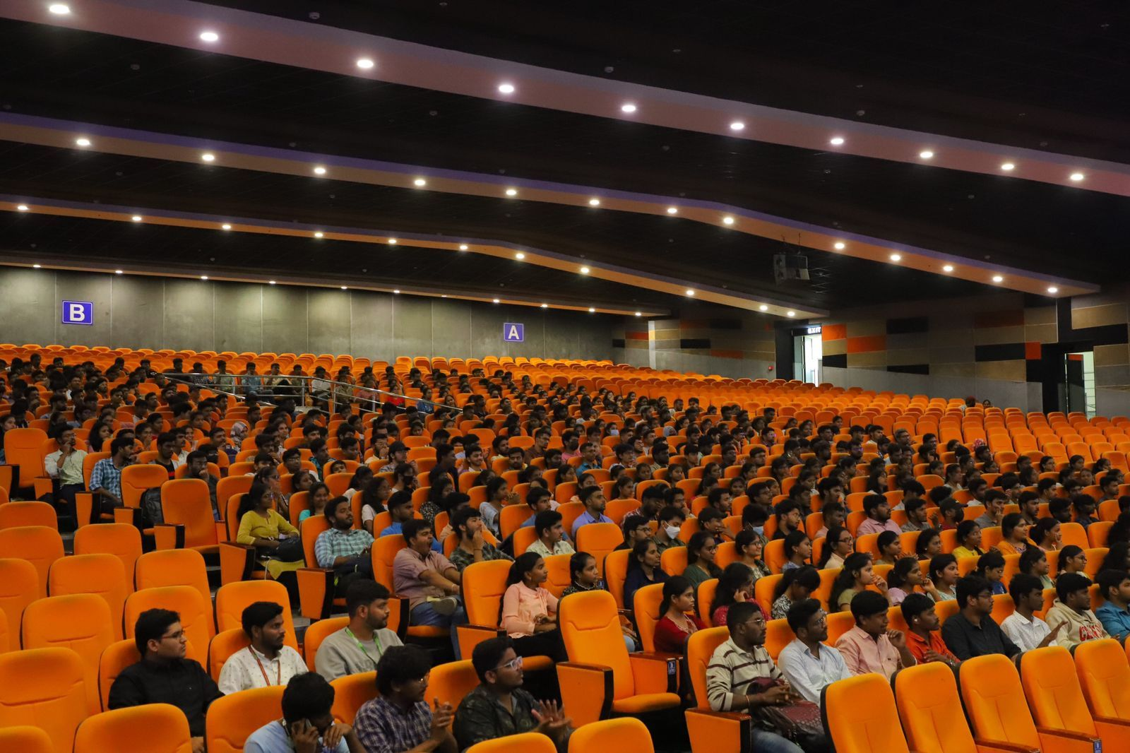

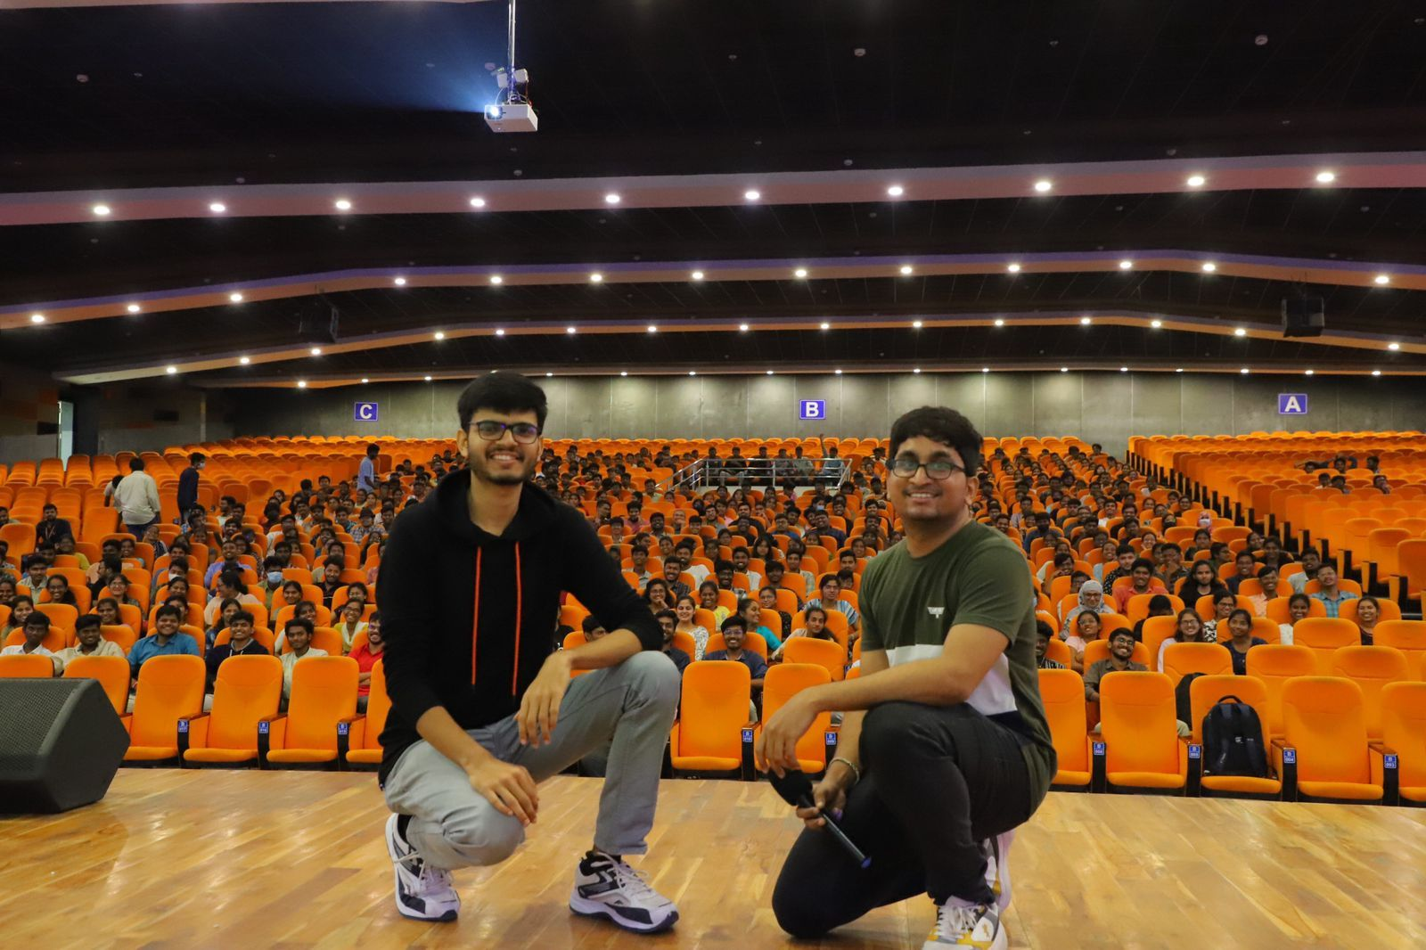

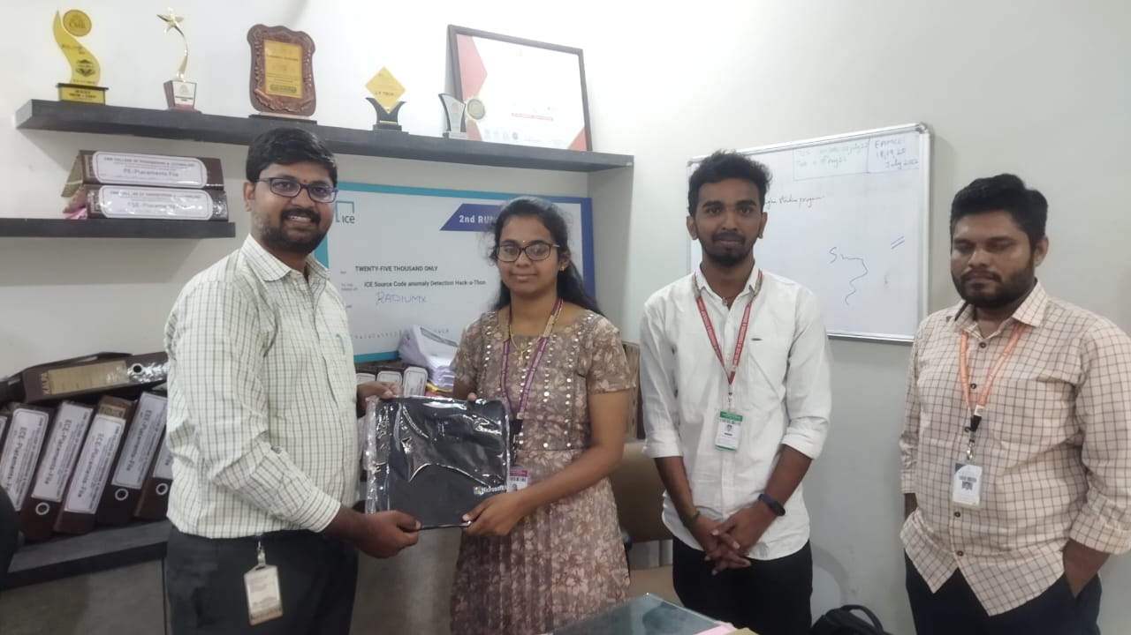

**Impact**

* Strengthened collaboration between **CMRCET and Microsoft Azure Developer Community**.
* Provided students with **direct industry exposure** and real-world insights.
* Motivated participants to pursue **Azure certifications and projects**.
* Built strong community engagement with support from faculty (under the guidance of **Dr. Hima Bindu**, Dean of Training & Placements).

**Event / Training Highlight – 2**

📅 **Date:** [November 2023]  
📍 **Location:** Microsoft Campus, Hyderabad  
🏢 **Organizer/Partner:** Reskilll & Azure Developer Community  
🎤 **Role:** Point of Contact (POC) & Community Lead

**Event Name**

*Code Without Barriers – Microsoft Campus Hyderabad*

**Description**

I had the opportunity to serve as a **Point of Contact and community organizer** for the **Code Without Barriers initiative** at Microsoft Campus, Hyderabad. This event championed **tech inclusivity and diversity**, creating a platform for students, developers, and professionals to engage with leading voices in the industry.

The event featured three phenomenal speakers:

* **Mansun Acharya**
* **Sahith Nayudu**
* **Siv Ram Shastri Jonnalagadda**

Together, they delivered impactful sessions on coding, innovation, and breaking barriers in tech.

* Audience: 150+ developers, students, and tech enthusiasts
* 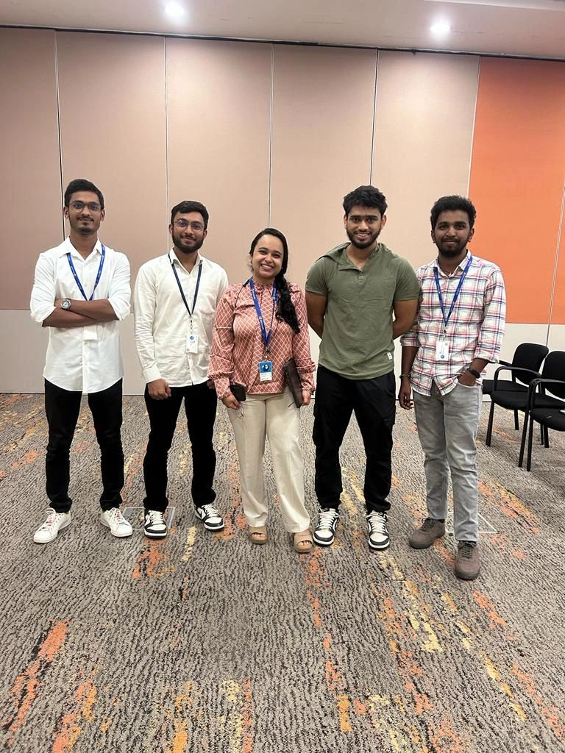Key Themes: **Tech inclusivity, coding best practices, Azure developer ecosystem**My Contribution: Coordinated with organizers, supported event setup and engagement, ensured smooth flow of sessions, and represented Reskilll as the community lead.

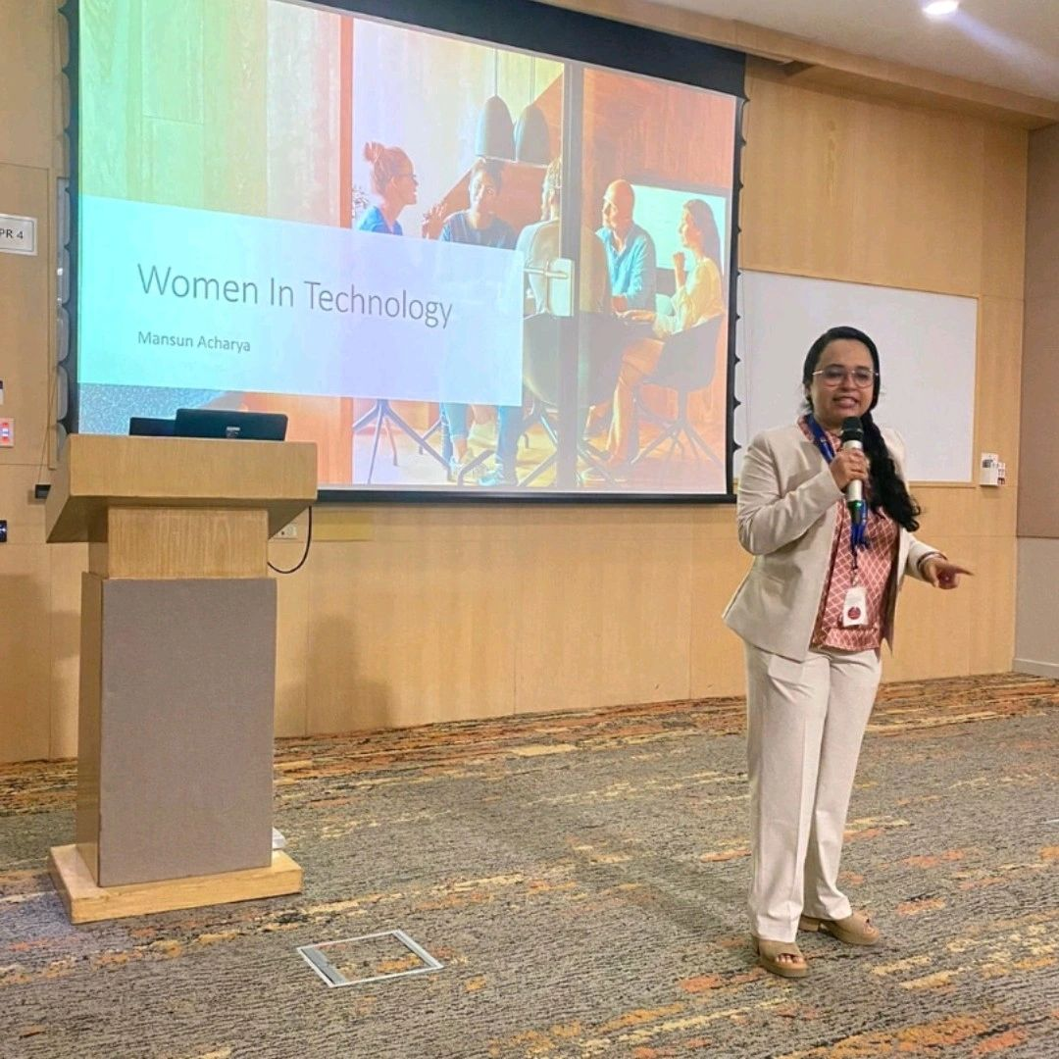

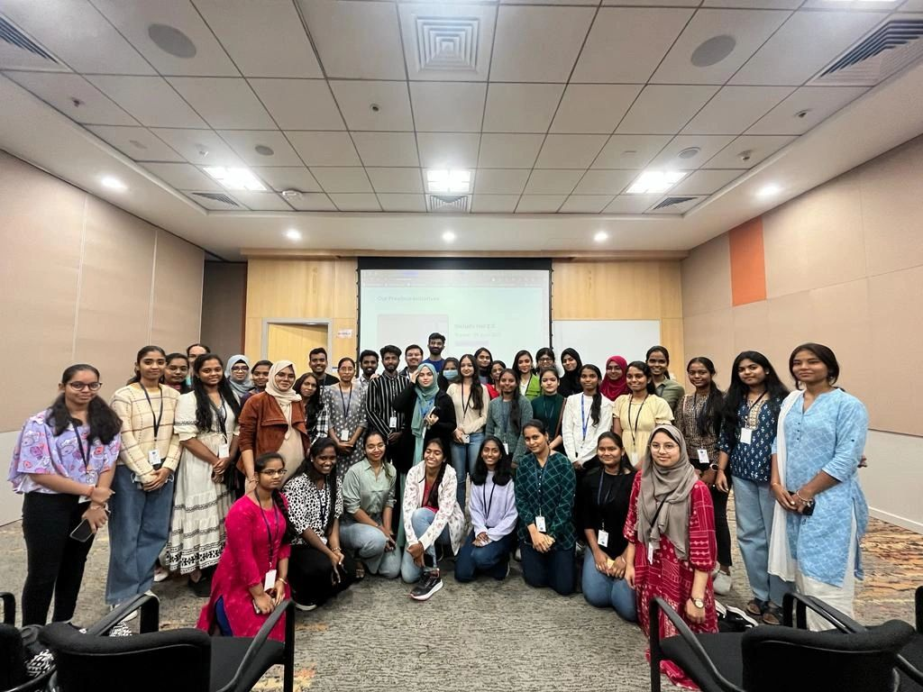

**Impact**

* Promoted the **Code Without Barriers mission** for inclusive growth in tech.
* Strengthened ties between **Reskilll, Microsoft, and Azure Developer Community**.
* Inspired attendees to **embrace coding without limitations** and leverage Azure tools.
* Built my experience in **large-scale event coordination and community management**.

**Event / Training Highlight – 3**

📅 **Date:** [December 2023]  
📍 **Location:** Microsoft Campus, Hyderabad  
🏢 **Organizer/Partner:** Reskilll & Azure Developer Community  
🎤 **Role:** Event Coordinator

**Event Name**

*AI Startup Mixer – Microsoft Campus Hyderabad*

**Description**

I had the privilege of coordinating the **AI Startup Mixer**, a dynamic event that brought together **AI innovators, startup enthusiasts, and tech professionals** at the Microsoft Campus in Hyderabad.

The event featured insightful talks by **Kiran R** and **Sanjana Yadav**, who shared their experiences on **AI adoption, startup growth, and innovation in the cloud ecosystem**.

As the **Event Coordinator**, I was responsible for managing event logistics, coordinating with speakers, and ensuring smooth execution of the sessions.

* Audience: 120+ AI and startup enthusiasts
* Duration: 1-day event
* Key Topics: AI innovation, startup challenges, Microsoft Azure ecosystem for entrepreneurs
* 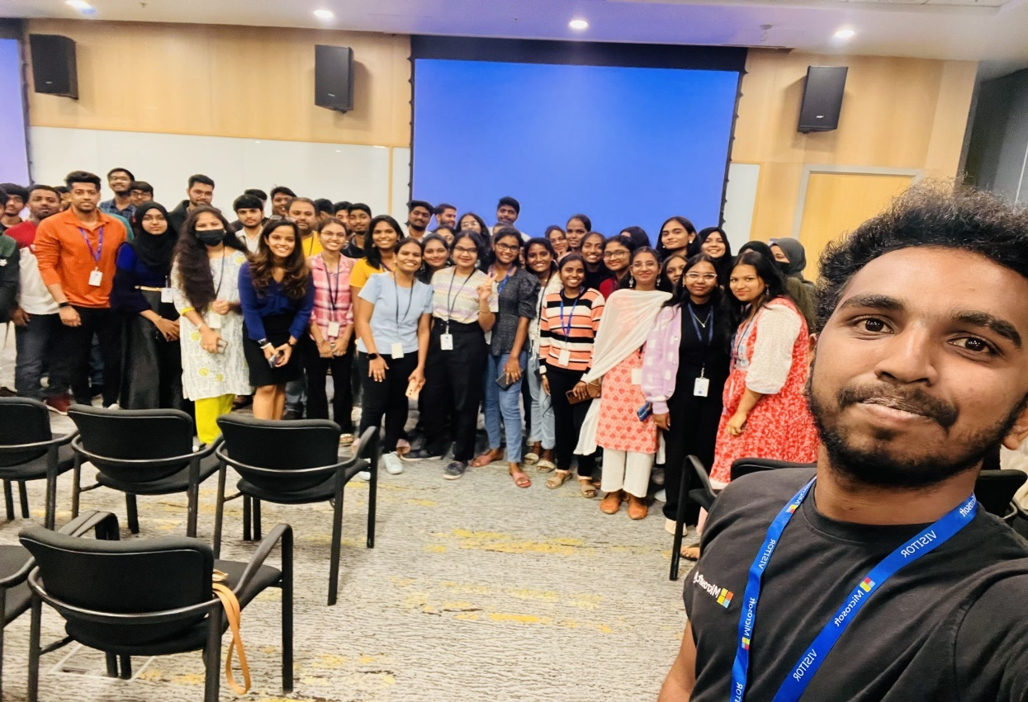My Contribution: Coordinated end-to-end event planning, engaged with attendees, and supported speaker sessions.

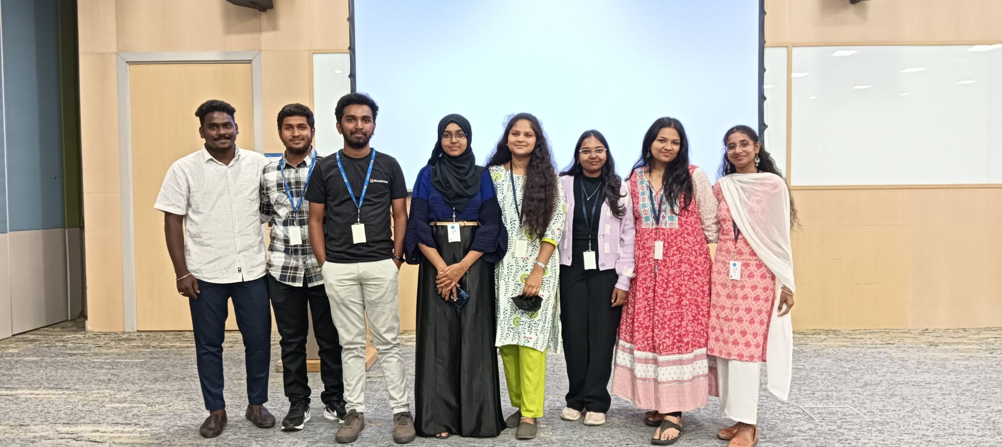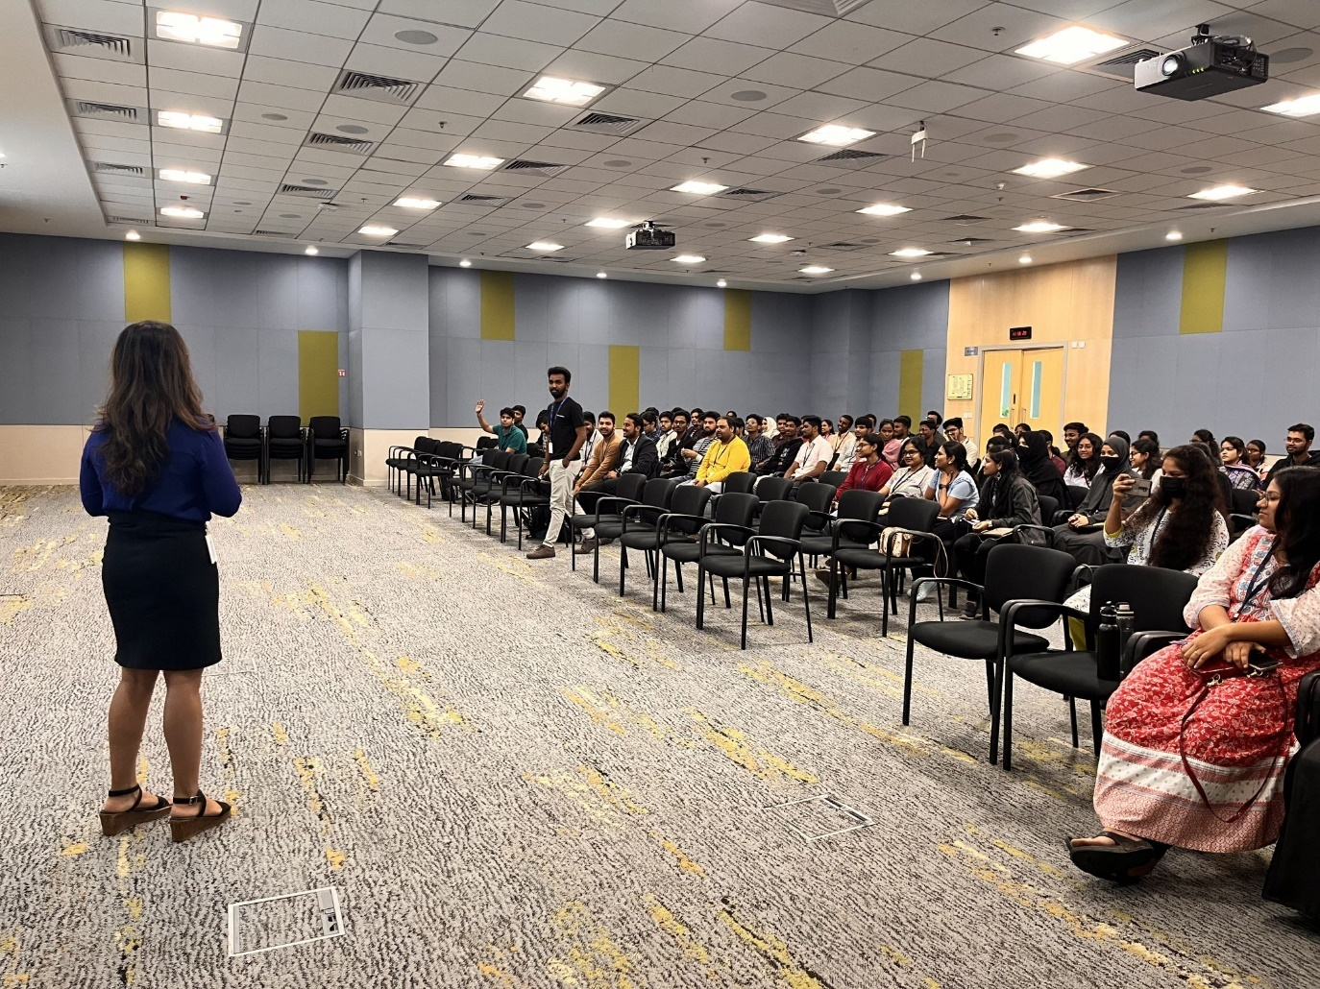

**Impact**

* Successfully connected **AI startups with Azure resources and community support**.
* Strengthened my role as a **community coordinator and event leader**.
* Promoted **entrepreneurship and AI innovation** within the Microsoft ecosystem.
* Enhanced community engagement with support from **Lakshit Pant** and the broader Azure Developer Community.

**Event / Training Highlight – 4**

📅 **Date:** 2024  
📍 **Location:** Microsoft AI Tour, Bangalore, India  
🏢 **Organizer/Partner:** Microsoft | Reskilll | Azure Developer Community  
🎤 **Role:** Participant (VIP Pass) & Community Contributor

**Event Name**

*Microsoft AI Tour 2024 – Bangalore*

**Description**

I had the privilege of participating in the **Microsoft AI Tour 2024** held in Bangalore, where I gained first-hand exposure to the latest developments in **artificial intelligence and cloud innovation**.

The event was highlighted by a **keynote from Satya Nadella (CEO of Microsoft)**, which emphasized the limitless opportunities that AI creates across industries. Guided by my mentor **Lakshit Pant**, I maximized my learning experience through workshops, networking, and technical challenges.

One of the key highlights was participating in the **AI Odyssey Challenge**, which tested participants’ skills in **applied AI problem-solving using Microsoft technologies**.

* Audience: Thousands of developers, industry leaders, and students
* Key Themes: **Future of AI, Azure AI Services, AI in enterprise solutions, developer opportunities**
* My Contribution: Represented the Azure Developer Community, engaged with industry leaders, and deepened my knowledge in AI through direct participation and challenges.

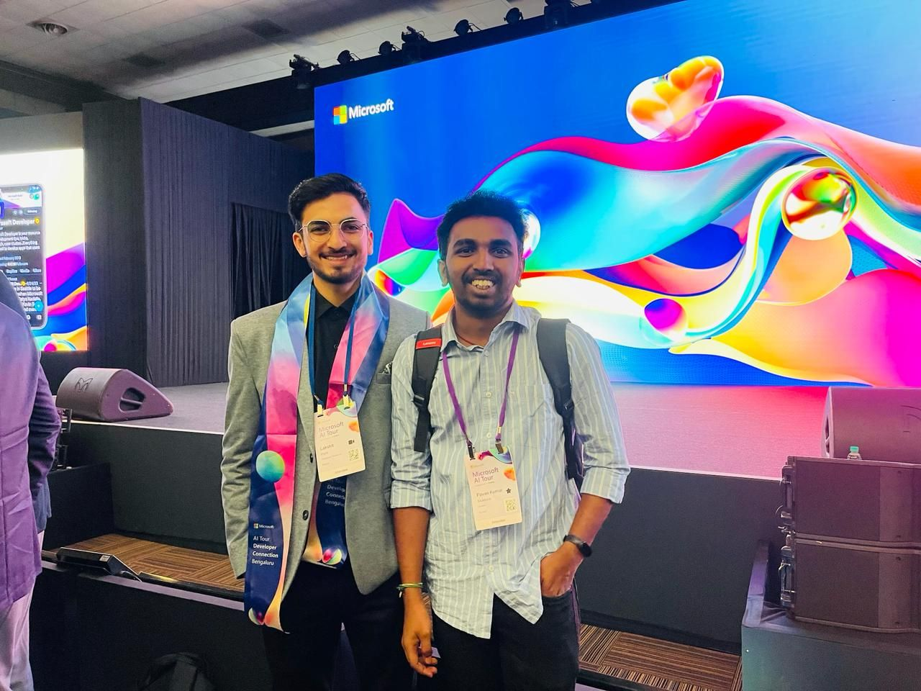

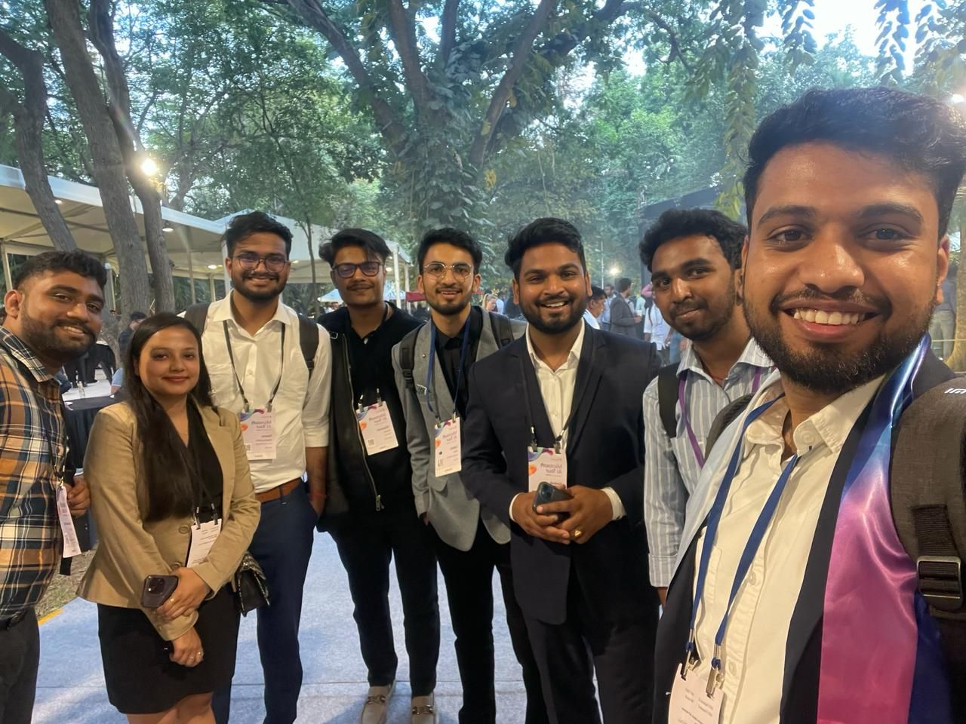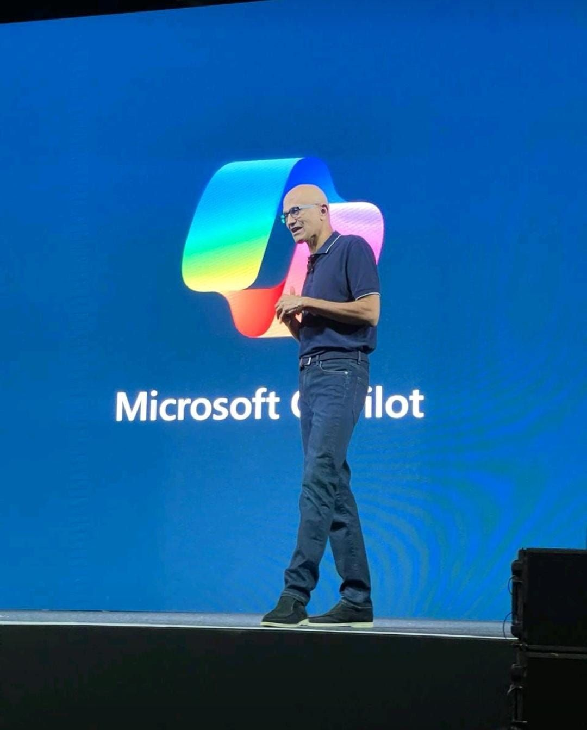

**Impact**

* Gained **exclusive insights** into Microsoft’s vision for AI, directly from leadership.
* Strengthened my **AI technical skills** and applied them in real-world challenge formats.
* Expanded professional network by connecting with **industry leaders and Microsoft experts**.
* Enhanced my ability to **bring back cutting-edge AI knowledge** to the community and future training sessions.

**Event / Training Highlight – 5**

📅 **Date:** [February 2024]  
📍 **Location:** Novotel, Hyderabad  
🏢 **Organizer/Partner:** Microsoft | Technical Spaces | Azure Developer Community  
🎤 **Role:** Lead Support & Community Coordinator

**Event Name**

*Microsoft AI Partner Training Roadshow – Hyderabad*

**Description**

I had the privilege of supporting and coordinating the **Microsoft AI Partner Training Roadshow** held at Novotel, Hyderabad. This event provided a **deep dive into Microsoft 365, AI integration, and partner-focused cloud solutions**, offering valuable learning for professionals and students alike.

The event featured impactful sessions from renowned speakers including **Gaurav Suresh Dharasa** and **Shivani Varma**, who delivered insights into modern AI practices, Microsoft 365 solutions, and industry adoption strategies.

I contributed as part of the **lead support team**, representing **Technical Spaces** and working closely with the organizing partners to ensure smooth operations and engagement.

* Audience: 100+ professionals and developers
* Key Themes: Microsoft 365, AI-powered business solutions, partner enablement, future of cloud adoption
* My Contribution: Coordinated with speakers, supported participant engagement, assisted in technical sessions, and represented community partners

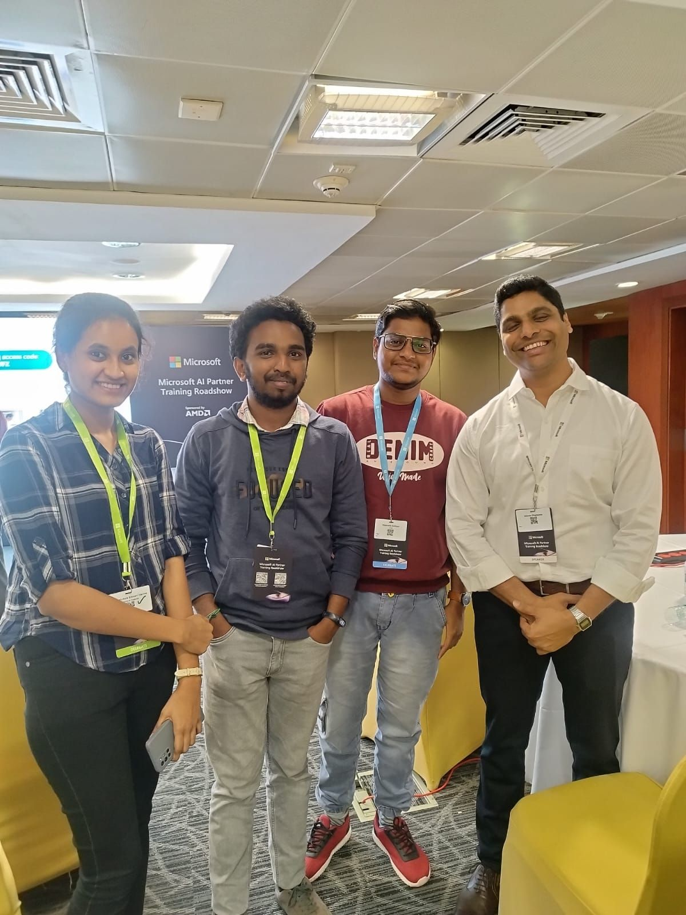

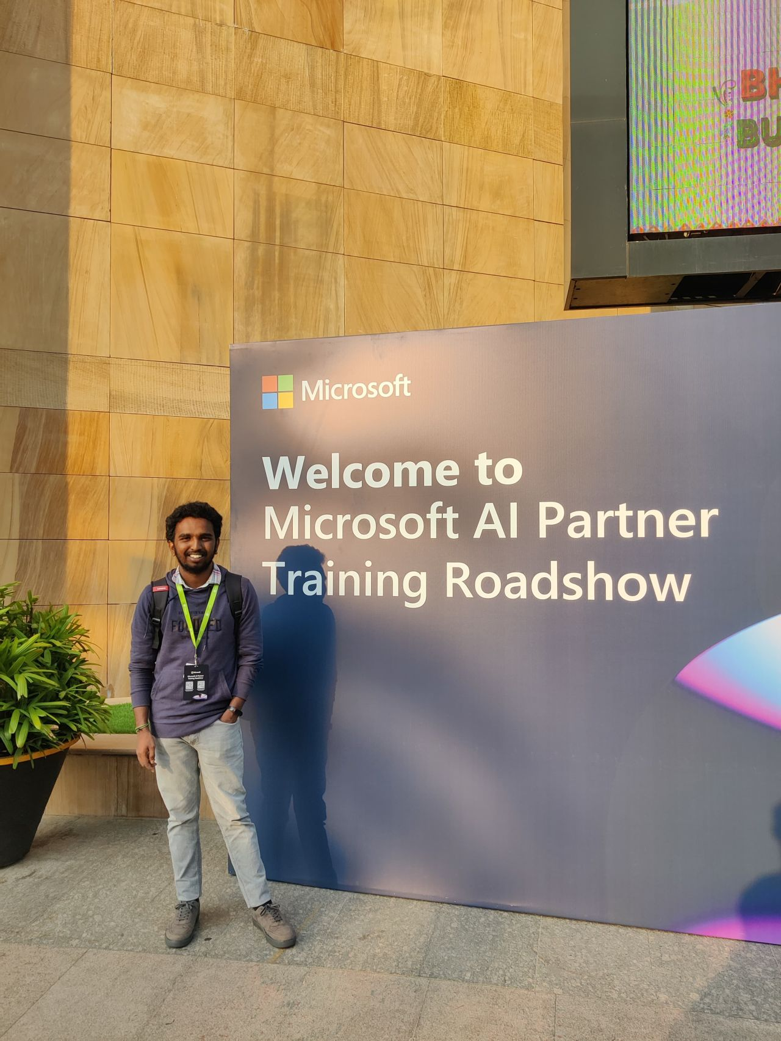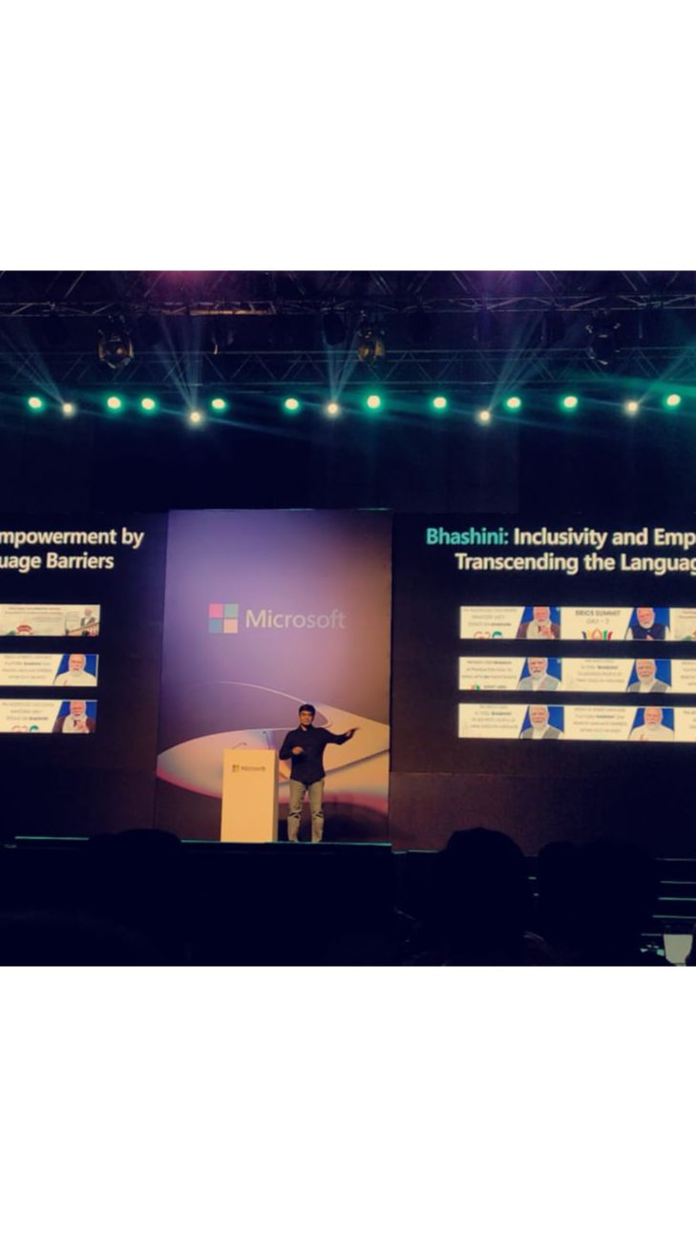

**Impact**

* Strengthened collaboration between **Microsoft, Technical Spaces, and the Azure Developer Community**.
* Enhanced professional knowledge of **Microsoft 365 and AI-powered tools**.
* Built connections with **industry speakers and partners**.
* Demonstrated leadership in **community support and technical event coordination**.

**Event / Training Highlight – 6**

📅 **Date:** 13th March 2024  
📍 **Location:** Government Polytechnic College, Gadwal (India)  
🏢 **Organizer/Partner:** Microsoft Azure | Reskilll | Azure Developer Community  
🎤 **Role:** Keynote Speaker

**Event Name**

*Azure Developer Day – Government Polytechnic College, Gadwal*

**Description**

I had the honor of returning to my **alma mater (Diploma, Class of 2021)** as a **Keynote Speaker** for the prestigious **Azure Developer Day 2024**. This event brought together aspiring developers, faculty, and students to explore the evolving landscape of **AI, cloud technologies, and the IT sector**.

I delivered a session on **cutting-edge AI solutions, Microsoft Azure services, and the future of IT careers**, aiming to spark curiosity and passion among the next generation of engineers.

The event was supported by key contributors including **Adithya Saladi** and **Lakshit Pant**, whose guidance and collaboration made the session impactful.

* Audience: 200+ diploma students and faculty
* Key Themes: **AI-driven innovation, Azure cloud services, industry career pathways**
* 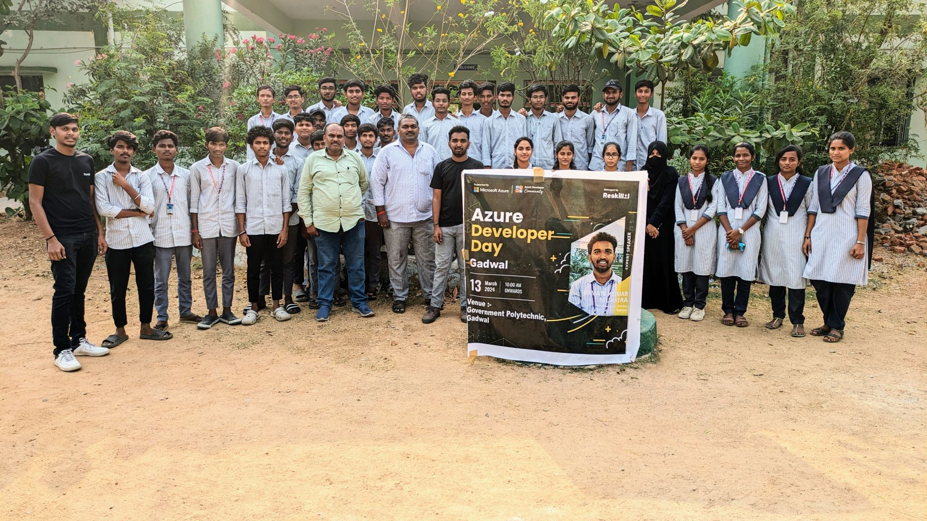My Contribution: Designed and delivered keynote presentation, engaged students in Q&A, inspired participants with real-world career insights and Azure case studies.

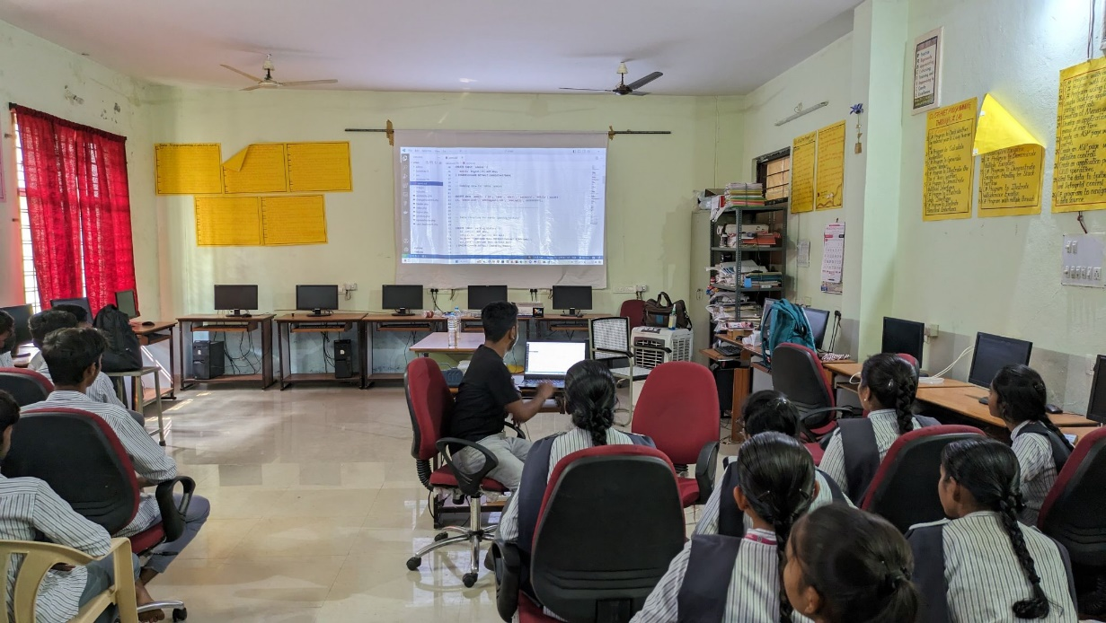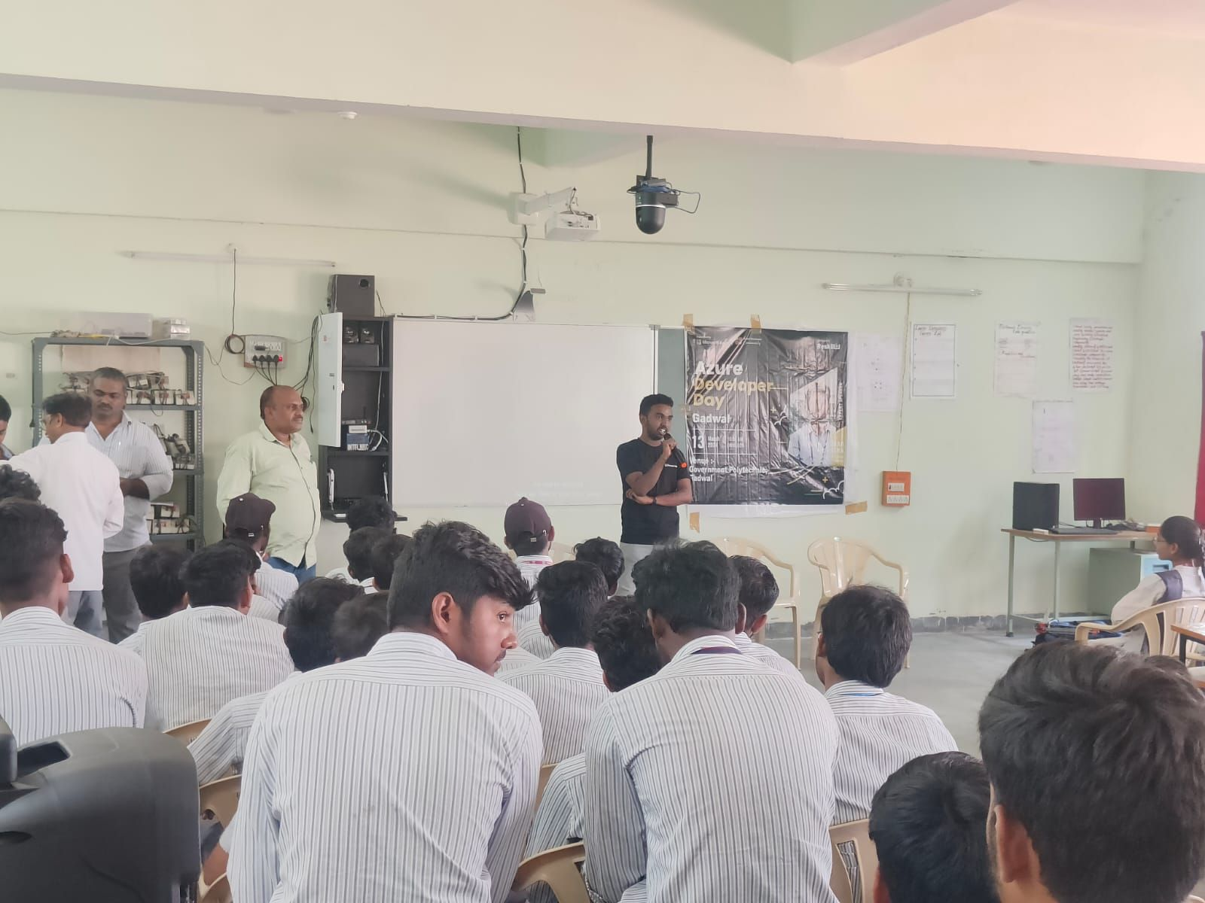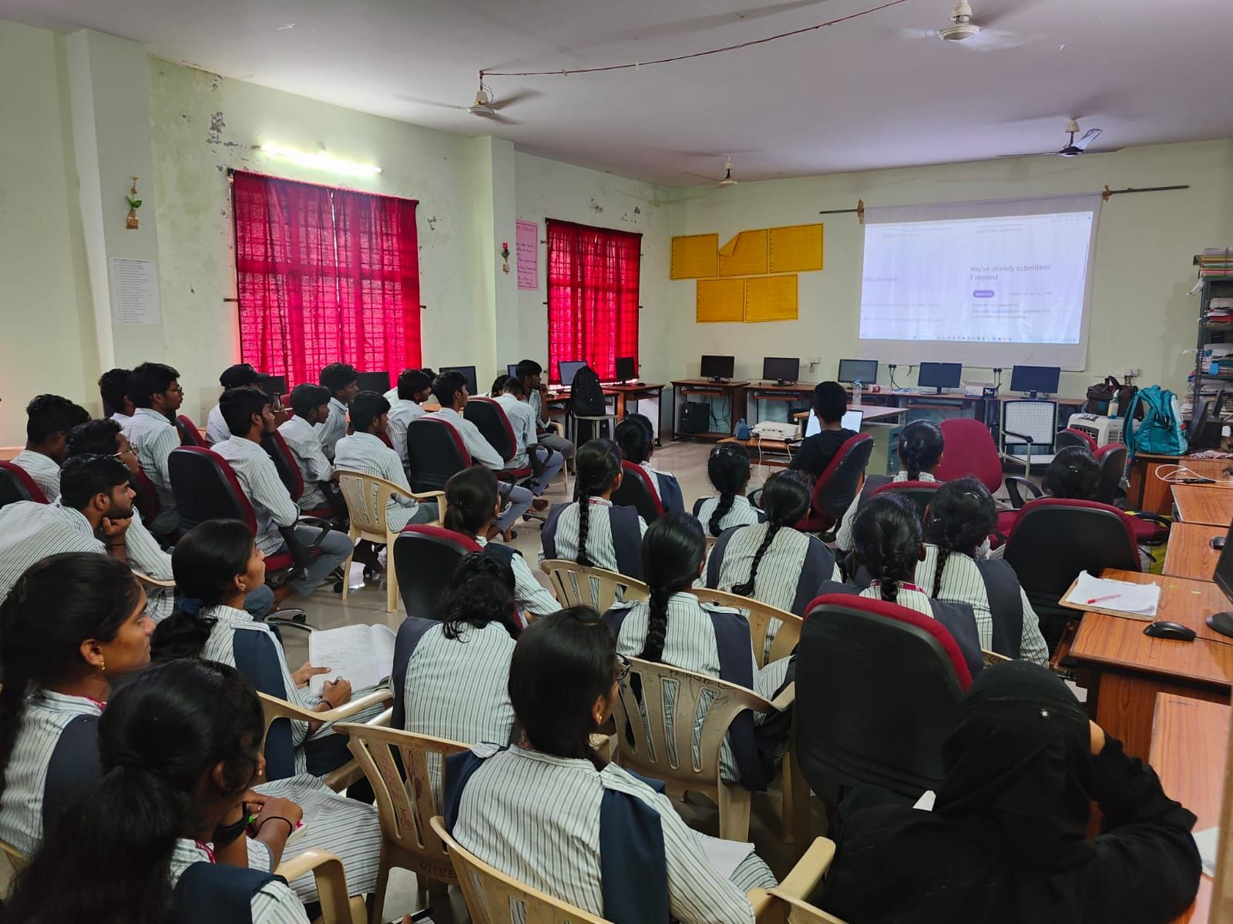

**Impact**

* Inspired diploma students to **embrace Microsoft Azure and AI** in their career journeys.
* Strengthened industry–academia collaboration by bringing **Azure Developer Community** directly to college campuses.
* Enhanced visibility of **Microsoft, Reskilll, and Azure Developer Community initiatives** in regional institutions.
* Personal milestone: returned to my alma mater as a **Keynote Speaker**, igniting young minds to pursue innovation.

**Event / Initiative Highlight – 7**

📅 **Date:** May 2024  
📍 **Region:** South India (Andhra Pradesh, Telangana, Karnataka, Goa, Maharashtra, Tamil Nadu)  
🏢 **Organizer/Partner:** Microsoft | Reskilll | Azure Developer Community  
🎤 **Role:** Regional Campaign Lead – South India

**Event Name**

*Microsoft Asia AI Odyssey Program – South India Campaign*

**Description**

As the **Regional Campaign Lead for South India**, I spearheaded the **Microsoft Asia AI Odyssey Program** across six key states — **Andhra Pradesh, Telangana, Karnataka, Goa, Maharashtra, and Tamil Nadu**. This campaign empowered thousands of students and professionals to participate in Microsoft’s **AI learning journey**, enhancing their skills in **Azure AI services, AI problem-solving, and global collaboration**.

In this role, I:

* Coordinated **campaign execution** across multiple states.
* Engaged with **universities, tech communities, and professionals** to drive participation.
* Promoted the program through LinkedIn campaigns, direct outreach, and community networks.
* Guided participants on **progress tracking, certification pathways, and completing AI challenges**.

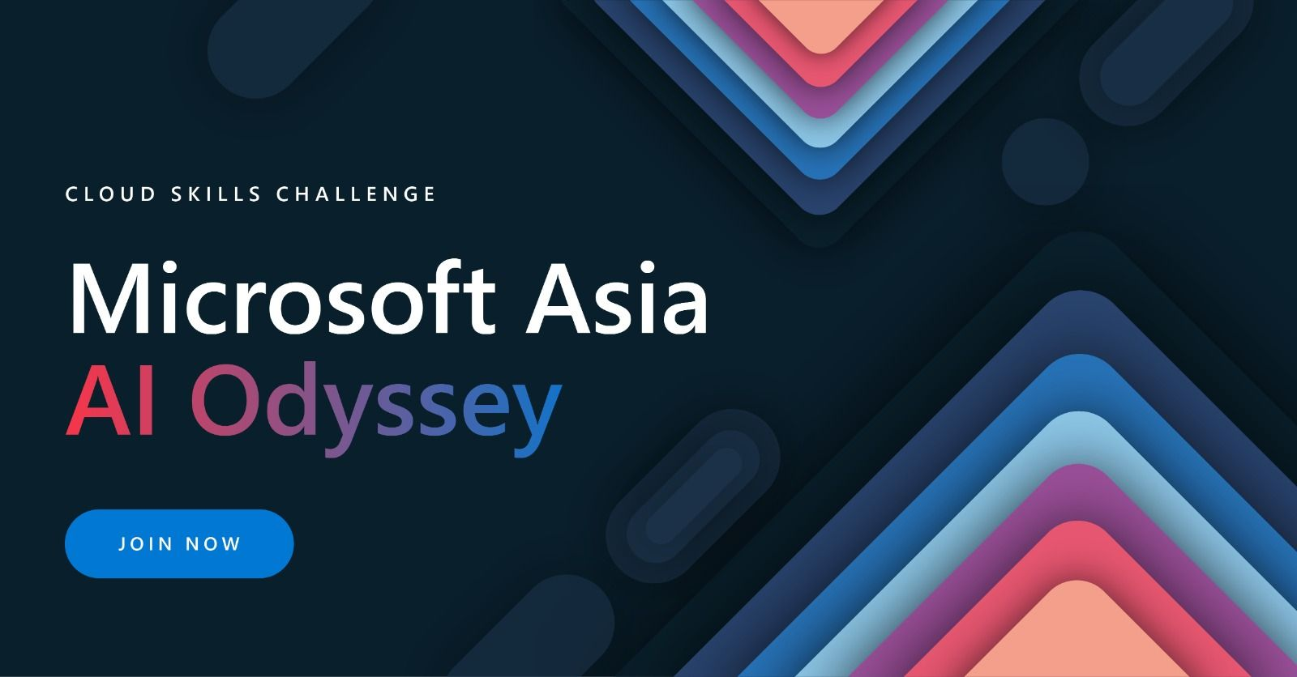

**Impact**

* Reached **5,000+ participants** across South India.
* Built strong collaborations with **colleges, developer communities, and Reskilll mentors**.
* Helped participants access **Azure certifications, mentorship, and global networking** opportunities.
* Strengthened my leadership profile as a **campaign strategist, community builder, and mentor** at a regional scale.

**Event / Training Highlight – 8**

📅 **Date:** April 2024  
📍 **Location:** Microsoft Campus, Hyderabad  
🏢 **Organizer/Partner:** Microsoft | Reskilll | Azure Developer Community  
🎤 **Role:** Community Lead & Event Host

**Event Name**

*Dev & Copilot Day – Microsoft Campus Hyderabad*

**Description**

As the **Community Lead**, I had the privilege of hosting **Dev & Copilot Day at Microsoft Campus, Hyderabad**, an event dedicated to exploring how **AI-powered copilots** are reshaping the developer ecosystem.

The event featured three outstanding speakers:

1. **Harika Nagidi** – *Software Development Consultant at Microsoft*  
   *Topic: Enhancing Developer Productivity With AI-Powered Copilots*
2. **Ankita Singh** – *Technical Consultant at Microsoft*  
   *Topic: The Role of Copilot in Automating Routine Tasks for Developers in M365*
3. **Shilpa Joshi** – *Cloud/DevOps Engineer at Deloitte*  
   *Topic: The Future of Cloud Computing: Trends and Predictions*

With the support of **Lakshit Pant** and **Azkar Uddin Khan**, and guidance from **Rohit Sardana**, the event was a huge success, engaging **students, developers, and IT professionals**.

* Audience: 150+ attendees
* Key Themes: AI copilots for developers, cloud computing trends, automation in M365
* 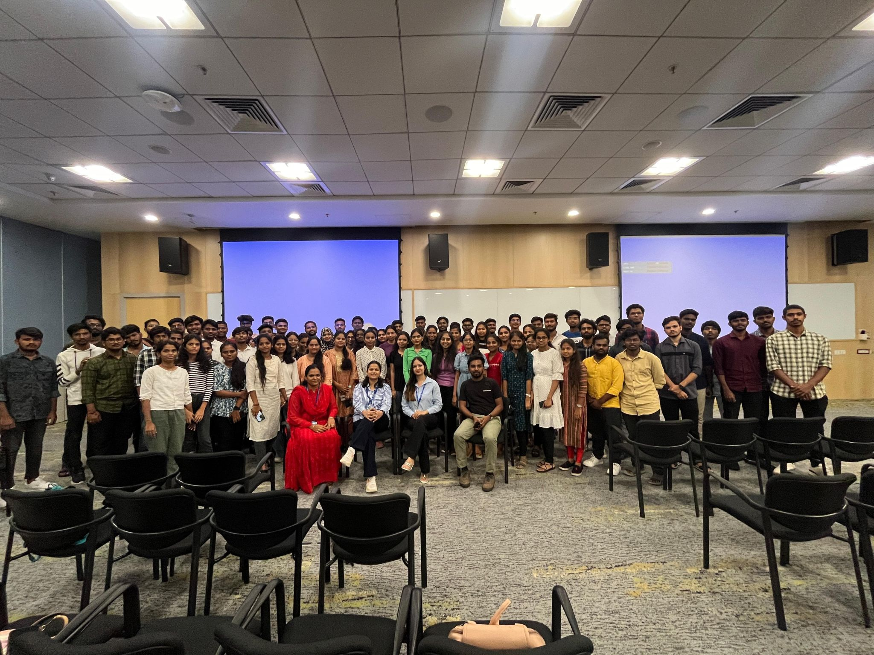My Contribution: Hosted the event, coordinated speaker sessions, managed Q&A, and led community engagement throughout the day.

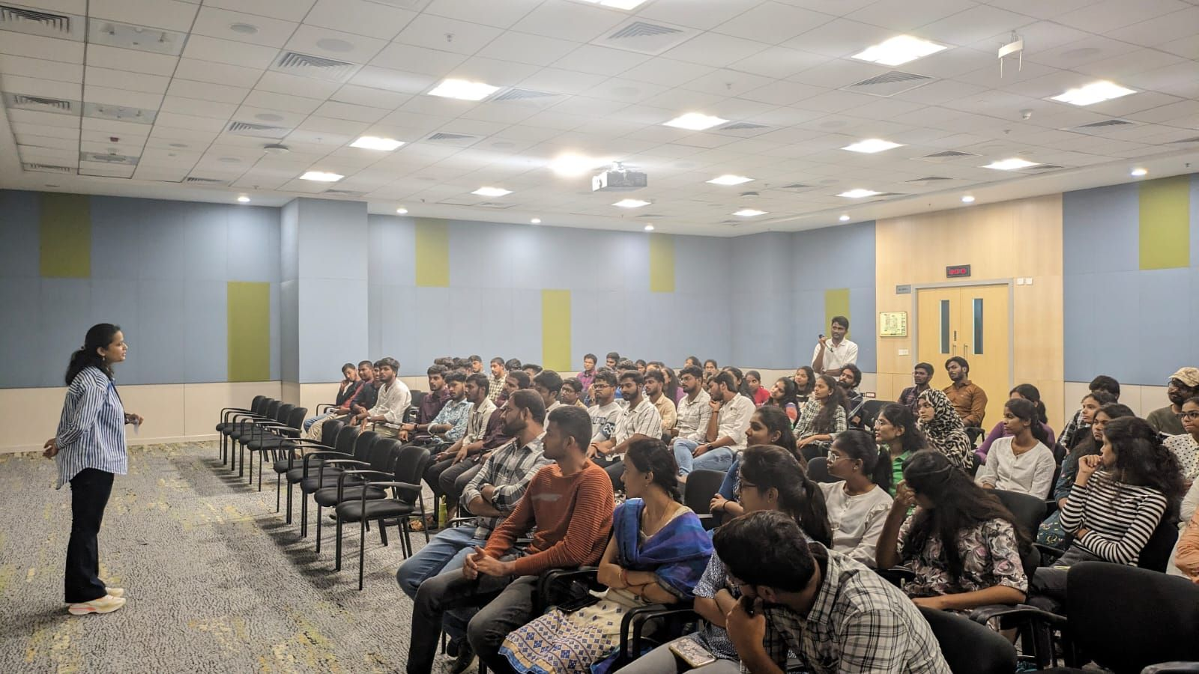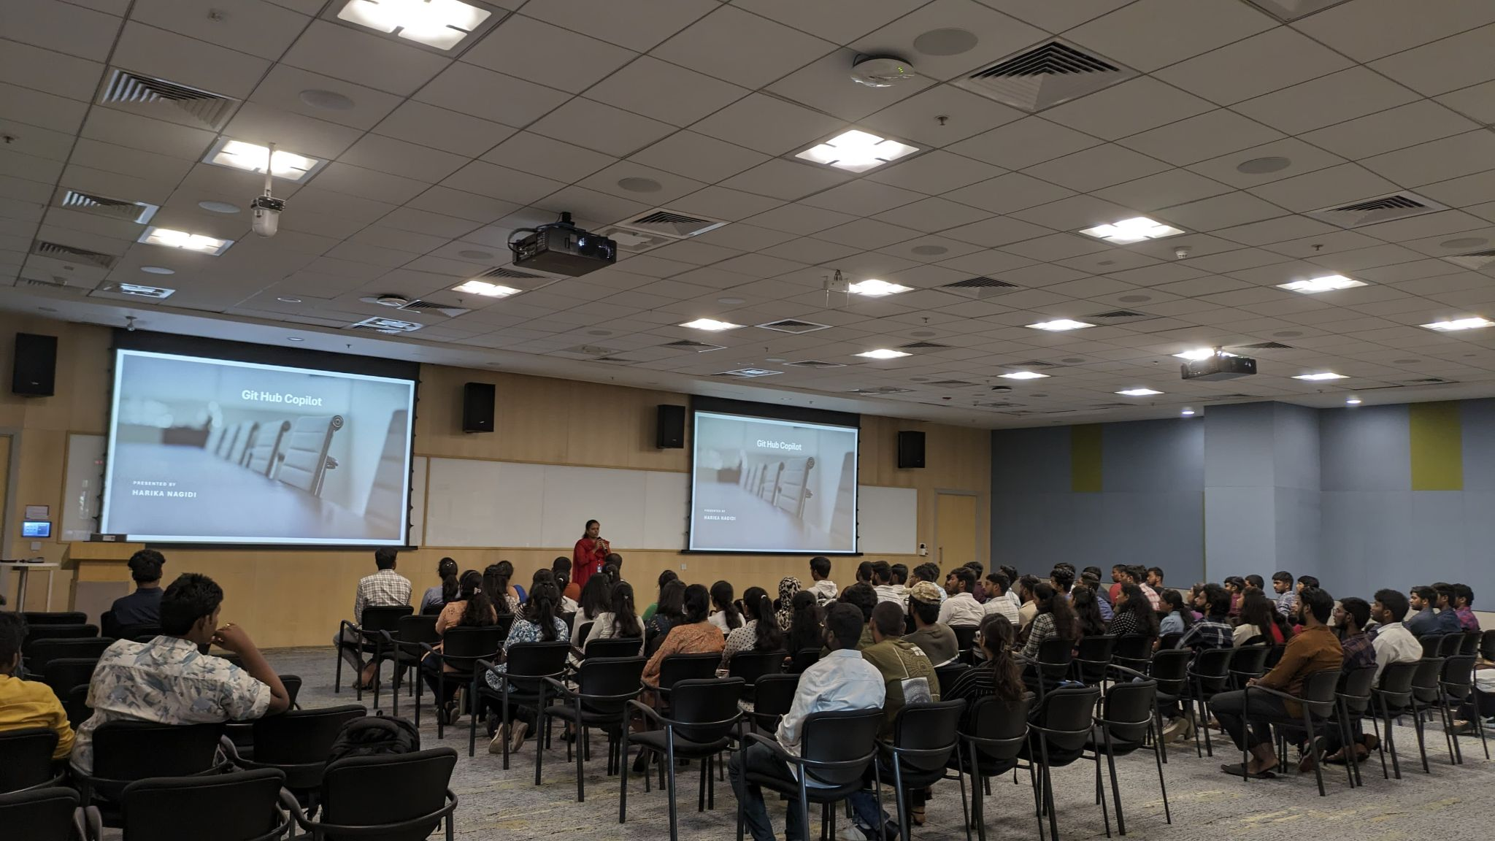

**Impact**

* Inspired developers to **adopt AI copilots and cloud tools** in their workflows.
* Strengthened my role as a **Community Lead and Event Host** at Microsoft Campus.
* Showcased **real-world applications of Microsoft AI and Copilot** for both students and professionals.
* Reinforced collaboration between **Microsoft, Deloitte, Reskilll, and the Azure Developer Community**.

**Event / Training Highlight – 9**

📅 **Date:** May 2024  
📍 **Location:** Microsoft Office, Hyderabad  
🏢 **Organizer/Partner:** Microsoft | Reskilll | Azure Developer Community  
🎤 **Role:** Event Lead

**Event Name**

*Azure Copilot Day – Microsoft Office Hyderabad*

**Description**

I had the privilege of serving as the **Lead** for the **Azure Copilot Day** hosted at the Microsoft office in Hyderabad. The event focused on showcasing the power of **Azure Copilot and AI-driven developer productivity tools**, drawing active participation from students, professionals, and community members.

The event featured esteemed speakers:

* **Saurabh Sharma** – Expert insights into Azure Copilot
* **Bhushan Kapkar** – Advanced applications of AI copilots in developer workflows

Special thanks to **Rohit Sardana**, **Azkar Uddin Khan**, and **Neha Lahamge (POC)** for their invaluable support in ensuring the event’s success.

* Audience: 120+ developers and tech enthusiasts
* Key Themes: AI copilots, Microsoft Azure innovation, developer productivity tools
* My Contribution: Coordinated end-to-end event logistics, engaged with speakers, managed community participation, and led the Azure Developer Community efforts

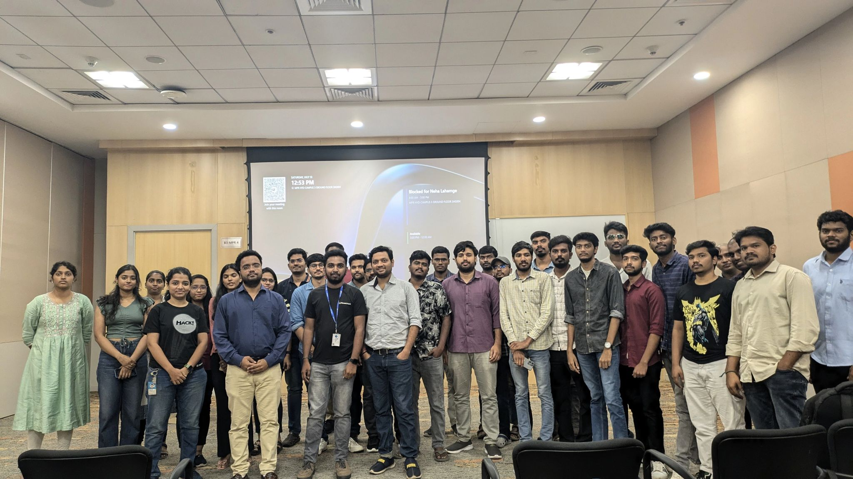

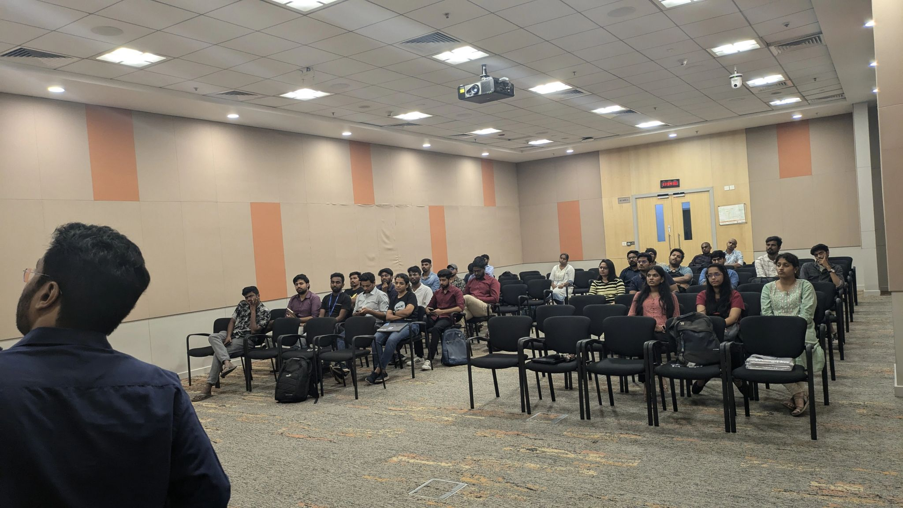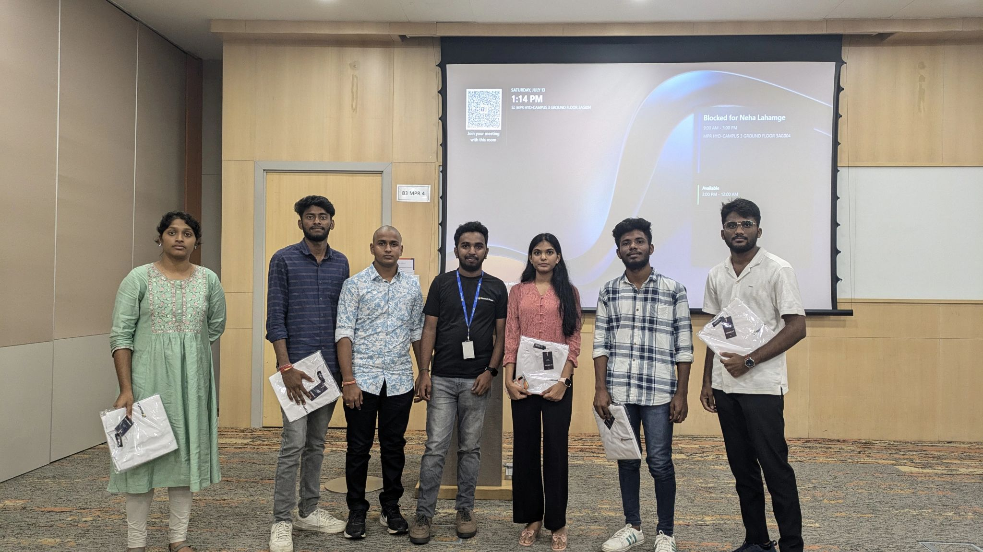

**Impact**

* Increased awareness and adoption of **Azure Copilot** within the developer community.
* Strengthened my skills in **event leadership, coordination, and technical community building**.
* Enhanced collaboration between **Microsoft, Reskilll, and the Azure Developer Community**.
* Empowered participants to explore **AI-powered solutions for real-world applications**.

**Event / Training Highlight – 10**

📅 **Date:** 20th July 2024  
📍 **Location:** Sumathi Reddy Institute of Technology for Women (SRITW), Warangal  
🏢 **Organizer/Partner:** Microsoft | Reskilll | Azure Developer Community  
🎤 **Role:** Event Lead

**Event Name**

*Azure Copilot Day – SRITW Warangal*

**Description**

I had the privilege of leading the **Azure Copilot Day at SRITW, Warangal**, a landmark event showcasing the future of **AI-powered productivity tools**. The sessions focused on **GitHub Copilot, Microsoft 365 Copilot, and Copilot Studio**, highlighting their role in revolutionizing developer productivity and enterprise collaboration.

The event featured insightful talks by Microsoft experts:

* **Harika Nagidi**
* **Shreyash Karmali**
* **Parameswar Kanuparthi**

With the support of **Reskilll leaders Rohit Sardana, Punit Jain, and Azkar Uddin Khan**, we successfully brought together students and professionals for an engaging day of learning and collaboration.

* Audience: 200+ participants (students, faculty, and developers)
* Key Themes: AI copilots, productivity transformation, collaboration tools, future of work
* My Contribution: Coordinated event planning, hosted speaker sessions, managed the Reskilll & Azure Developer Community presence, and inspired student participation

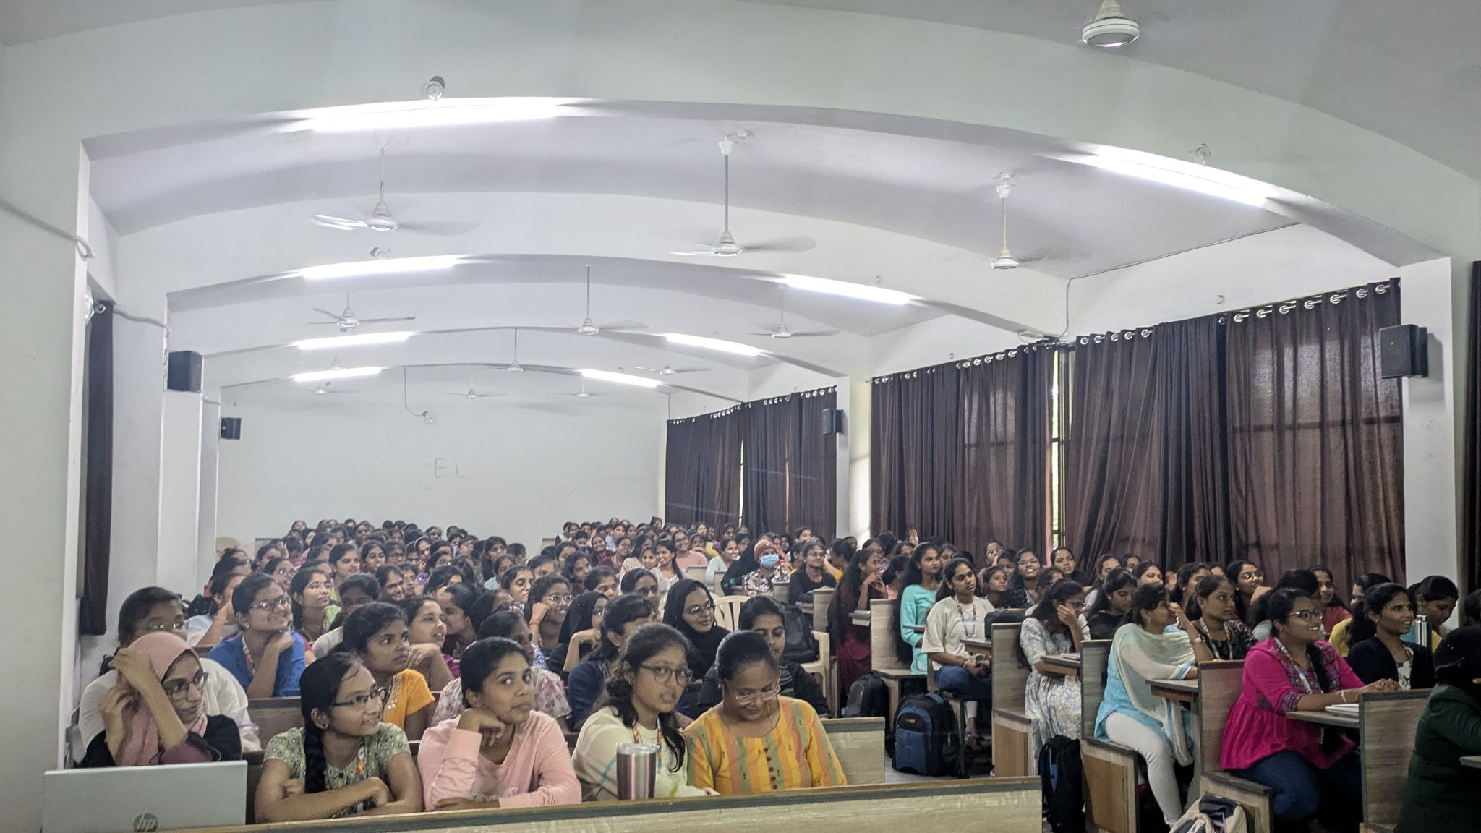

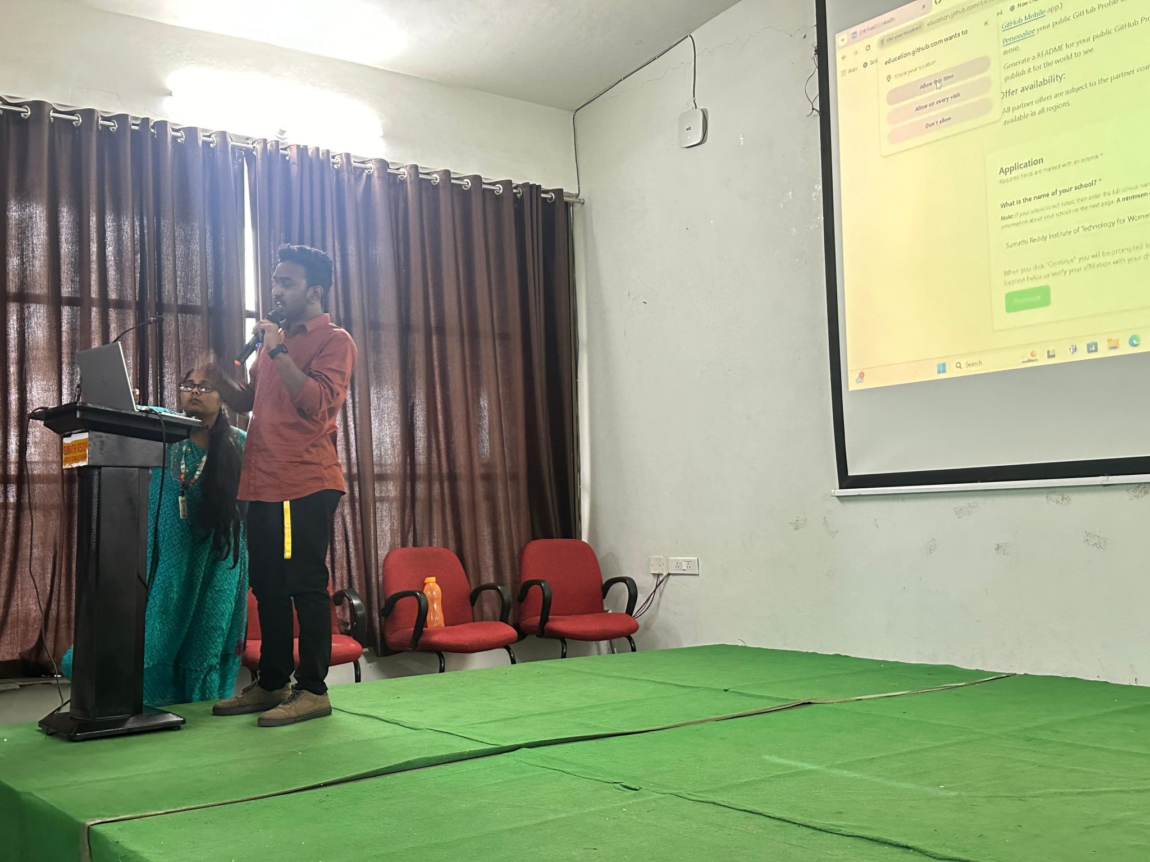

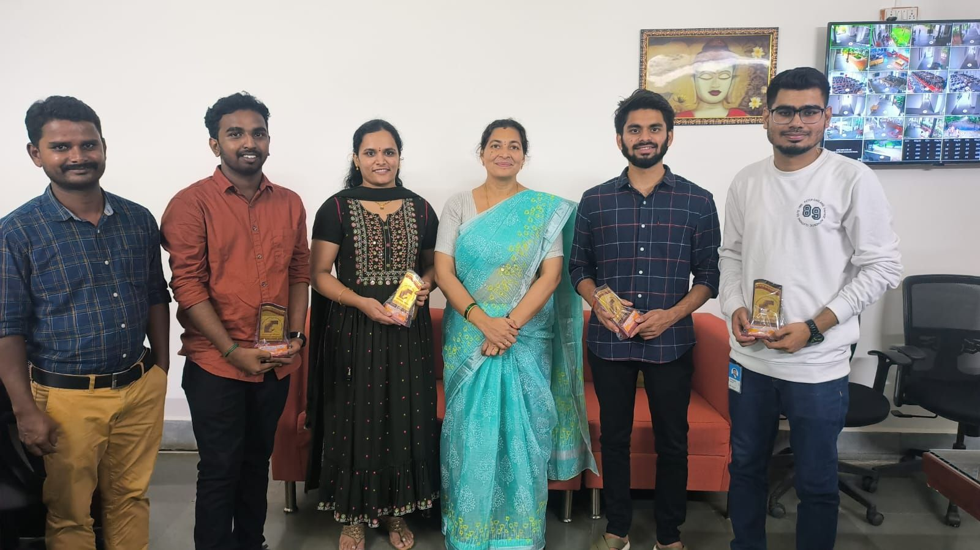

**Impact**

* Introduced **AI copilots** to a large student audience, bridging academia and industry innovation.
* Enhanced my leadership in **regional event management and technical training delivery**.
* Expanded the Azure Developer Community presence in **Tier-2/3 cities** like Warangal.
* Motivated students to explore **Azure certifications and AI projects**.

**Event / Training Highlight – 11**

📅 **Date:** August 2024  
📍 **Location:** Hyderabad, India  
🏢 **Organizer/Partner:** Microsoft | Reskilll | Azure Developer Community  
🎤 **Role:** Event Host & Lead Coordinator

**Event Name**

*Azure Copilot Day – Hyderabad*

**Description**

I had the privilege of **hosting the Azure Copilot Day in Hyderabad**, an event dedicated to exploring the future of **AI-powered copilots** and their role in transforming developer productivity and enterprise collaboration.

The event featured expert speakers:

* **Ankita Singh** – Microsoft
* **Nethra K** – Microsoft
* **Shivani Joshi** – Autodesk

They delivered inspiring sessions on **GitHub Copilot, Microsoft 365 Copilot, and Copilot Studio**, offering valuable perspectives for students, developers, and professionals.

Special appreciation goes to **Azkar Uddin Khan** for his dedicated support and to **Rohit Sardana** for his constant mentorship. The event was also supported by the **Azure Developer Community and Reskilll**, making it a truly collaborative success.

* Audience: 150+ students, professionals, and faculty
* Key Themes: GitHub Copilot, MS365 Copilot, Copilot Studio, AI-driven productivity tools
* 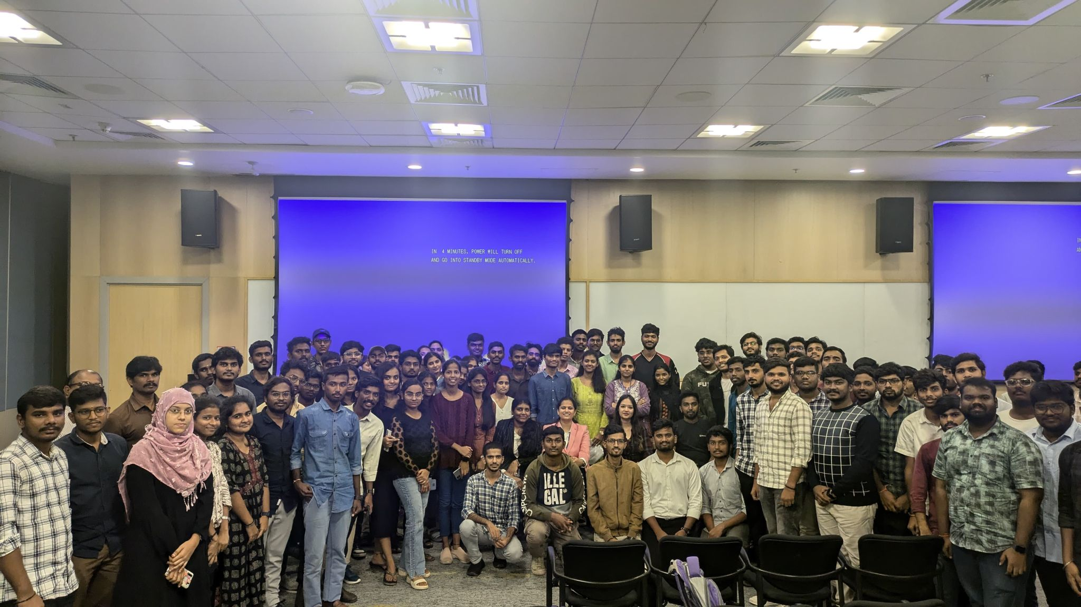My Contribution: Hosted and led the event, coordinated speaker sessions, ensured smooth logistics, and engaged participants throughout the program

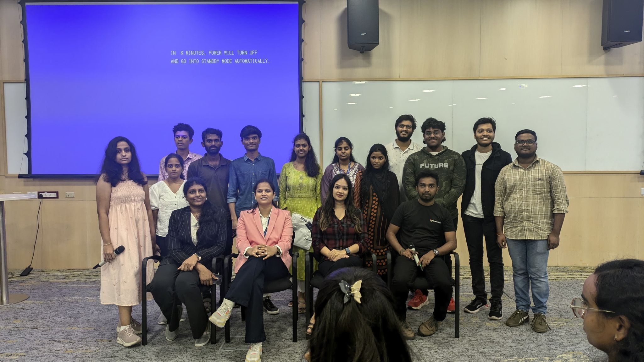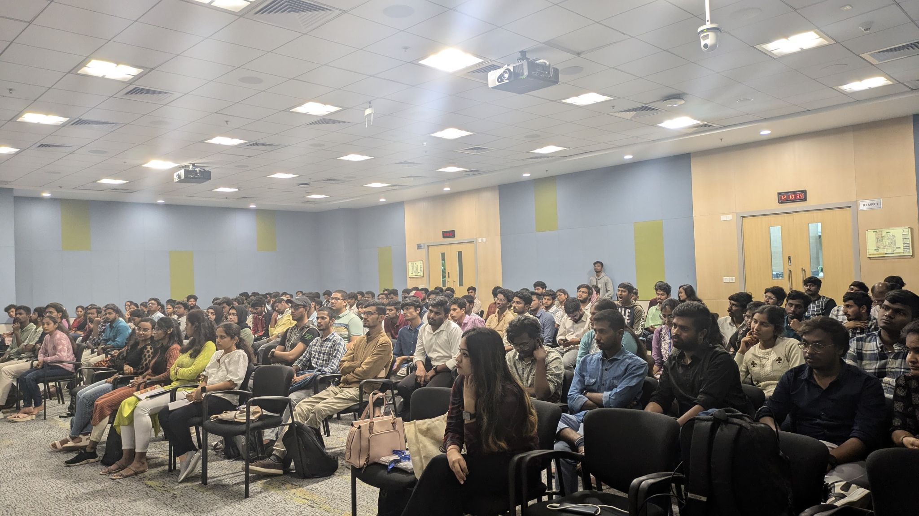

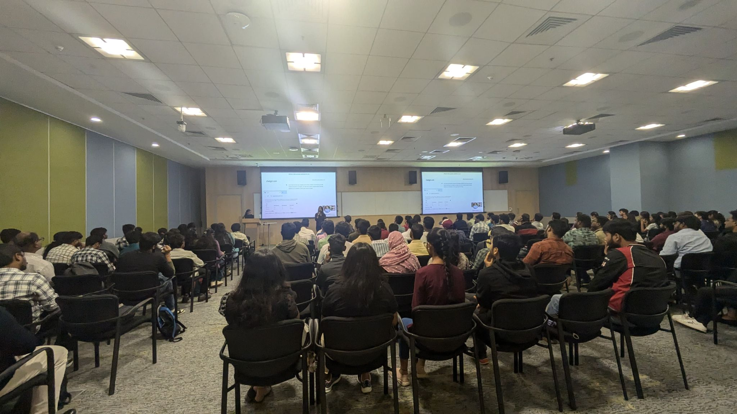

**Impact**

* Strengthened **Azure Copilot awareness and adoption** in the Hyderabad developer ecosystem.
* Enhanced my skills in **event hosting, leadership, and technical community engagement**.
* Built cross-industry collaboration between **Microsoft, Autodesk, Reskilll, and the Azure Developer Community**.
* Empowered participants to embrace **AI copilots in real-world development and productivity workflows**.

**Event / Training Highlight – 12**

📅 **Date:** 15th August 2024  
📍 **Location:** Microsoft Office, Hyderabad  
🏢 **Organizer/Partner:** Microsoft | Reskilll | Azure Developer Community  
🎤 **Role:** Community Lead

**Event Name**

*Azure AI & Copilot Day – Microsoft Hyderabad*

**Description**

As a **Community Lead**, I had the privilege of hosting the **Azure AI & Copilot Day** at the Microsoft Office in Hyderabad. The event brought together a vibrant community of **AI enthusiasts, developers, and tech professionals** to explore the future of AI and Copilot technologies.

The sessions featured distinguished Microsoft speakers:

* **Adithya Saladi** – *Software Engineer 2, Microsoft*  
  *Topic: Introduction to Azure AI*
* **Sanjana Yadav** – *Product & Programs, Office of VP, Product Experiences, Microsoft*  
  *Topic: Exploring GitHub Copilot for Developers*
* **Ravindra Penumarthi** – *Security Engineer, Microsoft*  
  *Topic: Live Demos of Azure AI & GitHub Copilot*

The event included **interactive demos, real-world applications, and a live Q&A session**, sparking deep engagement and curiosity among participants.

* Audience: 200+ attendees (students, developers, professionals)
* Key Themes: Azure AI, GitHub Copilot, AI-assisted development, productivity transformation
* 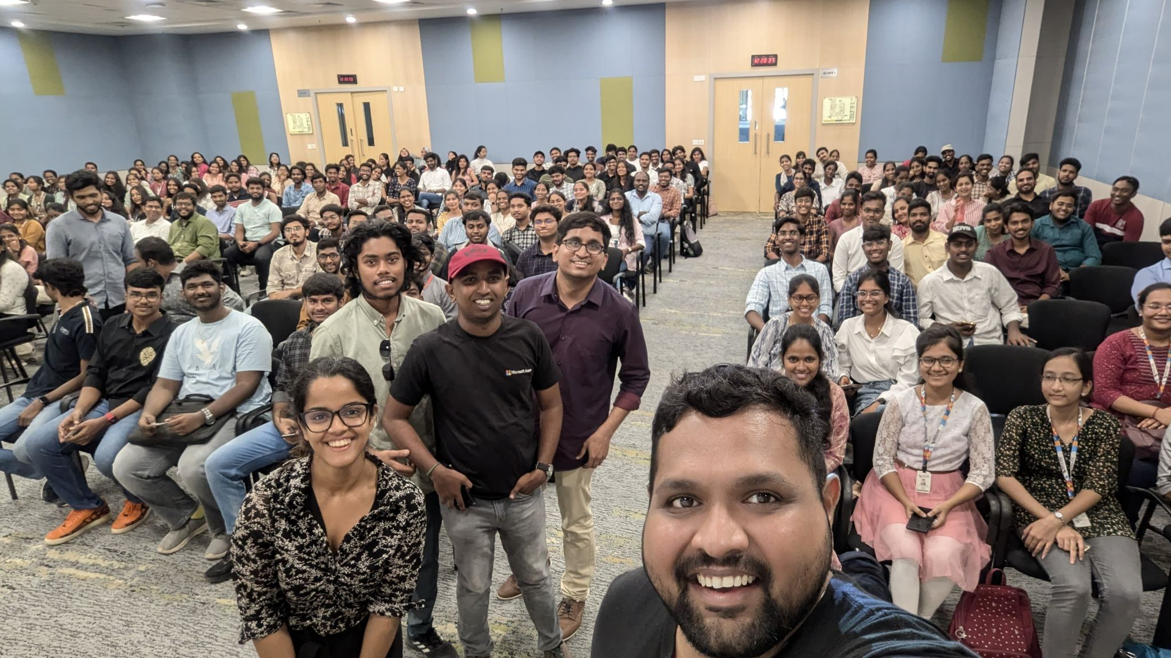My Contribution: Led the event as **Community Lead**, coordinated with speakers, managed engagement, and ensured smooth event delivery with the support of Reskilll and the Azure Developer Community

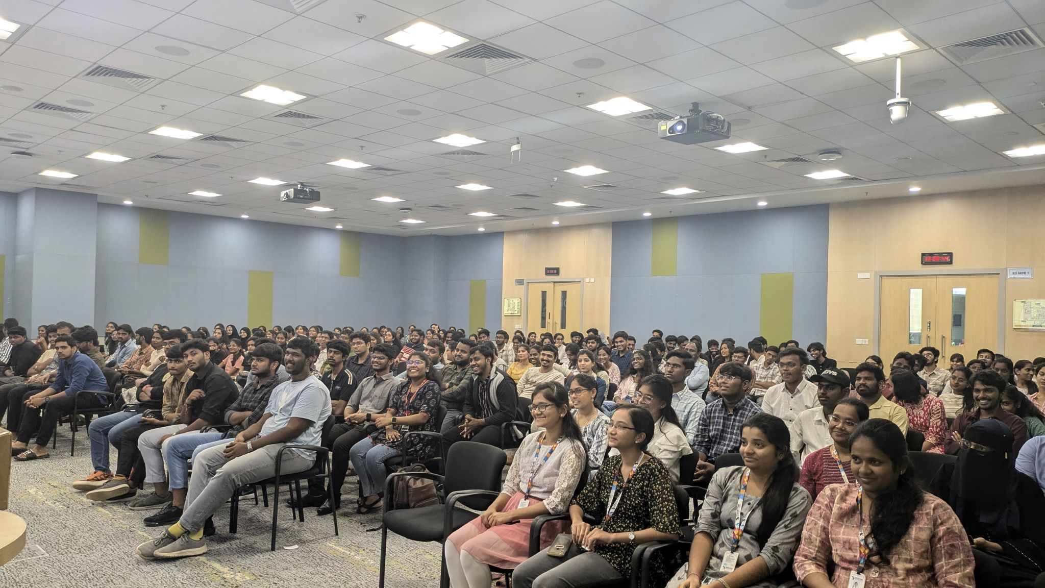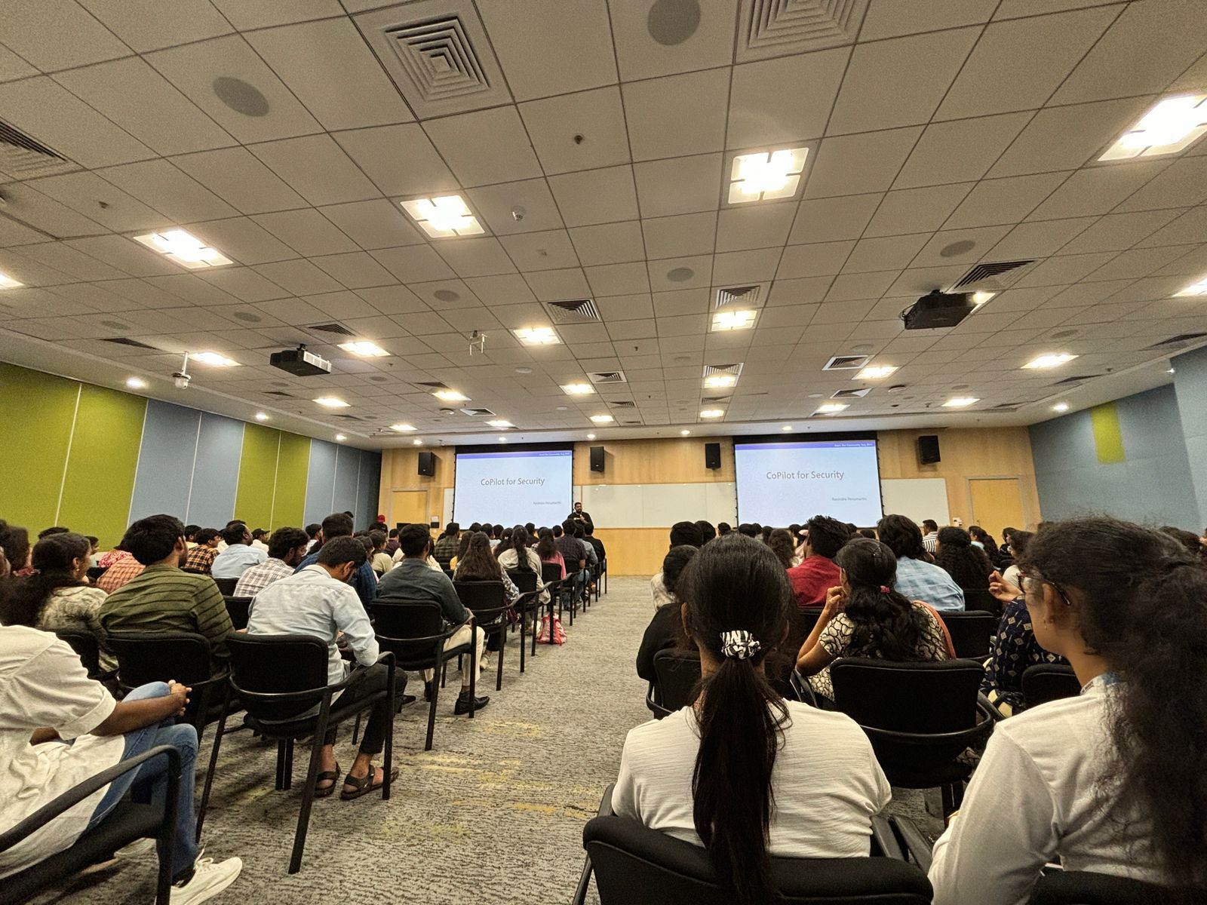

**Impact**

* Empowered participants to **adopt Azure AI & GitHub Copilot** in real-world projects.
* Strengthened my leadership as a **Community Lead and Event Organizer** at Microsoft Hyderabad.
* Enhanced collaboration between **Microsoft, Reskilll, and the Azure Developer Community**.
* Extended community learning by planning the **next event (31st August 2024)** to include more participants.

**Event / Training Highlight – 13**

📅 **Date:** August 2024  
📍 **Location:** KL University, Hyderabad  
🏢 **Organizer/Partner:** KL University | Microsoft | Reskilll | Azure Developer Community  
🎤 **Role:** Workshop Host & Speaker

**Event Name**

*Azure Developers Day – KL University Hyderabad*

**Description**

I had the privilege of hosting and delivering sessions at **Azure Developers Day** at KL University, Hyderabad. The workshop introduced students and faculty to **Microsoft Azure, GitHub Student Pack, and AI-driven developer tools**, with the goal of sparking innovation and building hands-on cloud skills.

The event featured distinguished speakers from Microsoft:

* **Harika Nagidi**
* **Nethra K**
* **Ankita Singh**

Alongside their expert talks, I delivered a presentation on the **GitHub Student Pack**, guiding students on how to leverage free developer resources to accelerate their learning journey.

* Audience: 250+ students and faculty members
* Key Themes: Microsoft Azure, Azure DevOps, Azure OpenAI, GitHub Student Pack, Cloud adoption
* 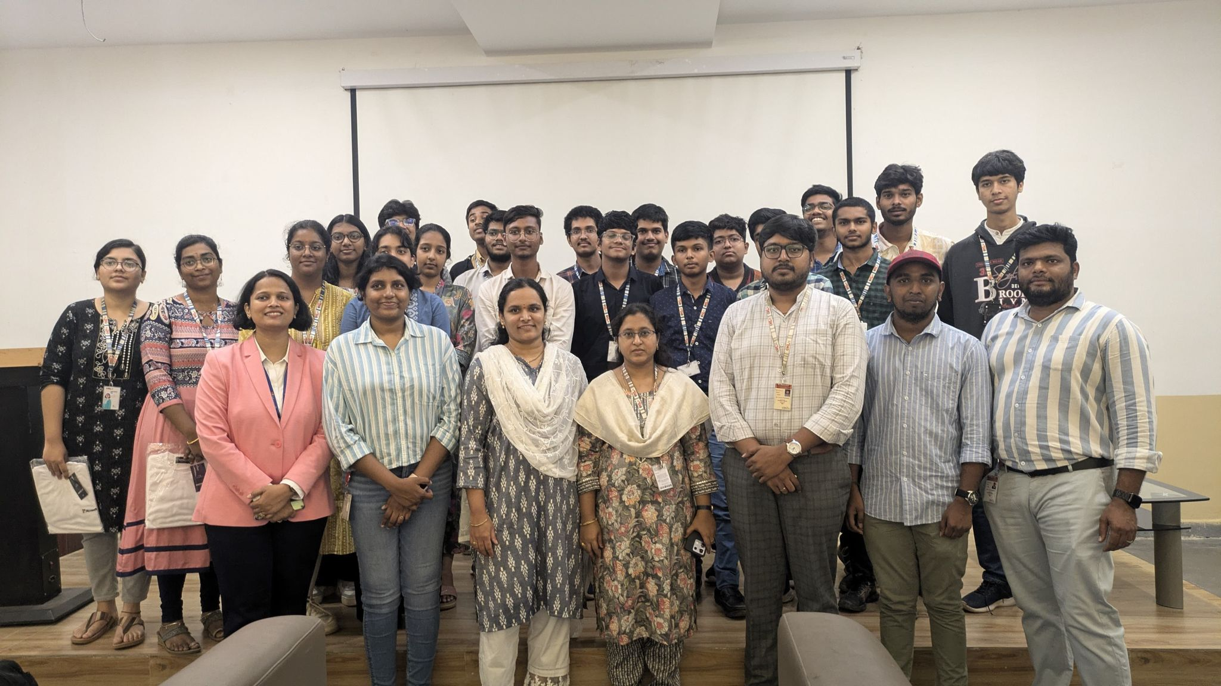My Contribution: Hosted the event, presented a session on GitHub Student Pack, supported participants in learning resources, and coordinated with KL University staff and Reskilll partners

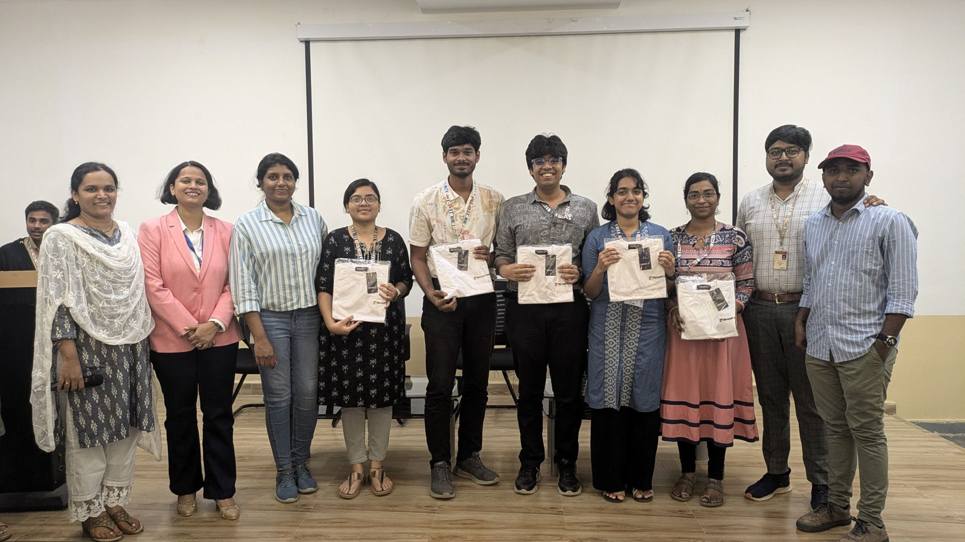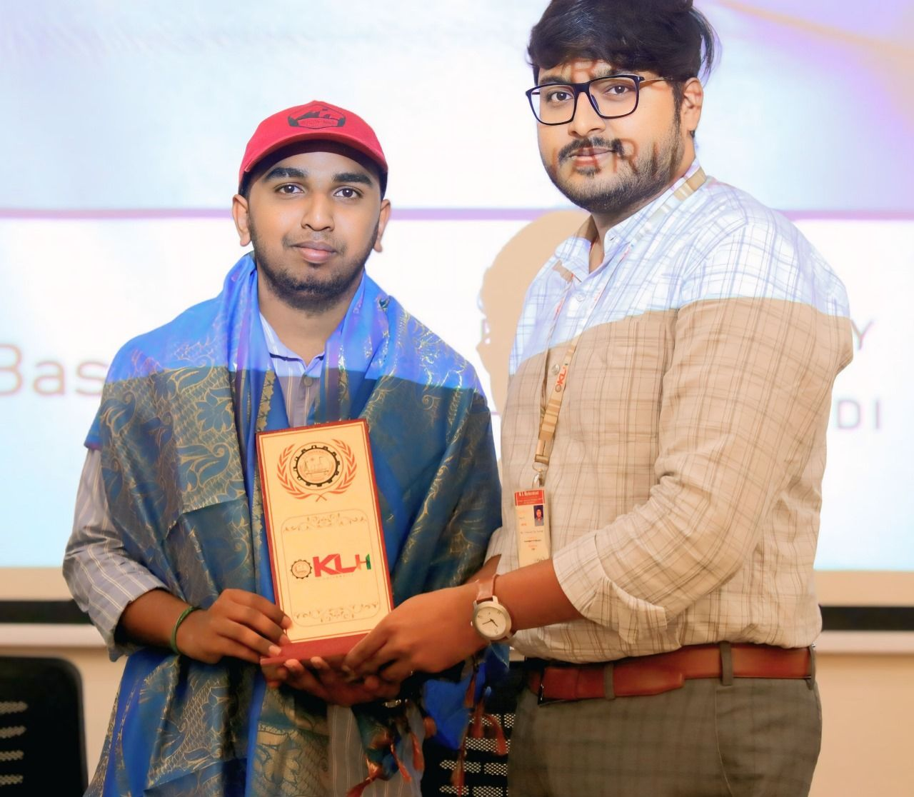

**Impact**

* Introduced students to **Azure cloud adoption and GitHub resources**.
* Empowered attendees with tools for **AI, cloud, and open-source development**.
* Strengthened collaboration between **Microsoft, KL University, Reskilll, and the Azure Developer Community**.
* Enhanced my skills as a **speaker, trainer, and technical mentor** for student developers.

**Event / Training Highlight – 14**

📅 **Date:** 12th September 2024  
📍 **Location:** Malla Reddy College of Engineering, Hyderabad  
🏢 **Organizer/Partner:** Microsoft | Reskilll | Azure Developer Community  
🎤 **Role:** Community Representative & Speaker

**Event Name**

*Azure Dev Day – Malla Reddy College of Engineering*

**Description**

I had the honor of representing **Reskilll and the Azure Developer Community** at **Azure Dev Day** hosted at Malla Reddy College of Engineering, Hyderabad. The event was designed to empower students with hands-on exposure to **Azure AI services, cloud innovation, and professional growth opportunities**.

The event featured exceptional Microsoft speakers:

* **Ankita Singh** – Consultant II, Microsoft
* **Nethra K** – Senior Consultant, Microsoft

I contributed by guiding participants through **Azure AI adoption, networking opportunities, and resources such as the GitHub Student Developer Pack**, helping them gain valuable tools to advance their learning journey.

* Audience: 200+ students and faculty
* Key Themes: Azure AI, student developer tools, career mentorship, community collaboration
* 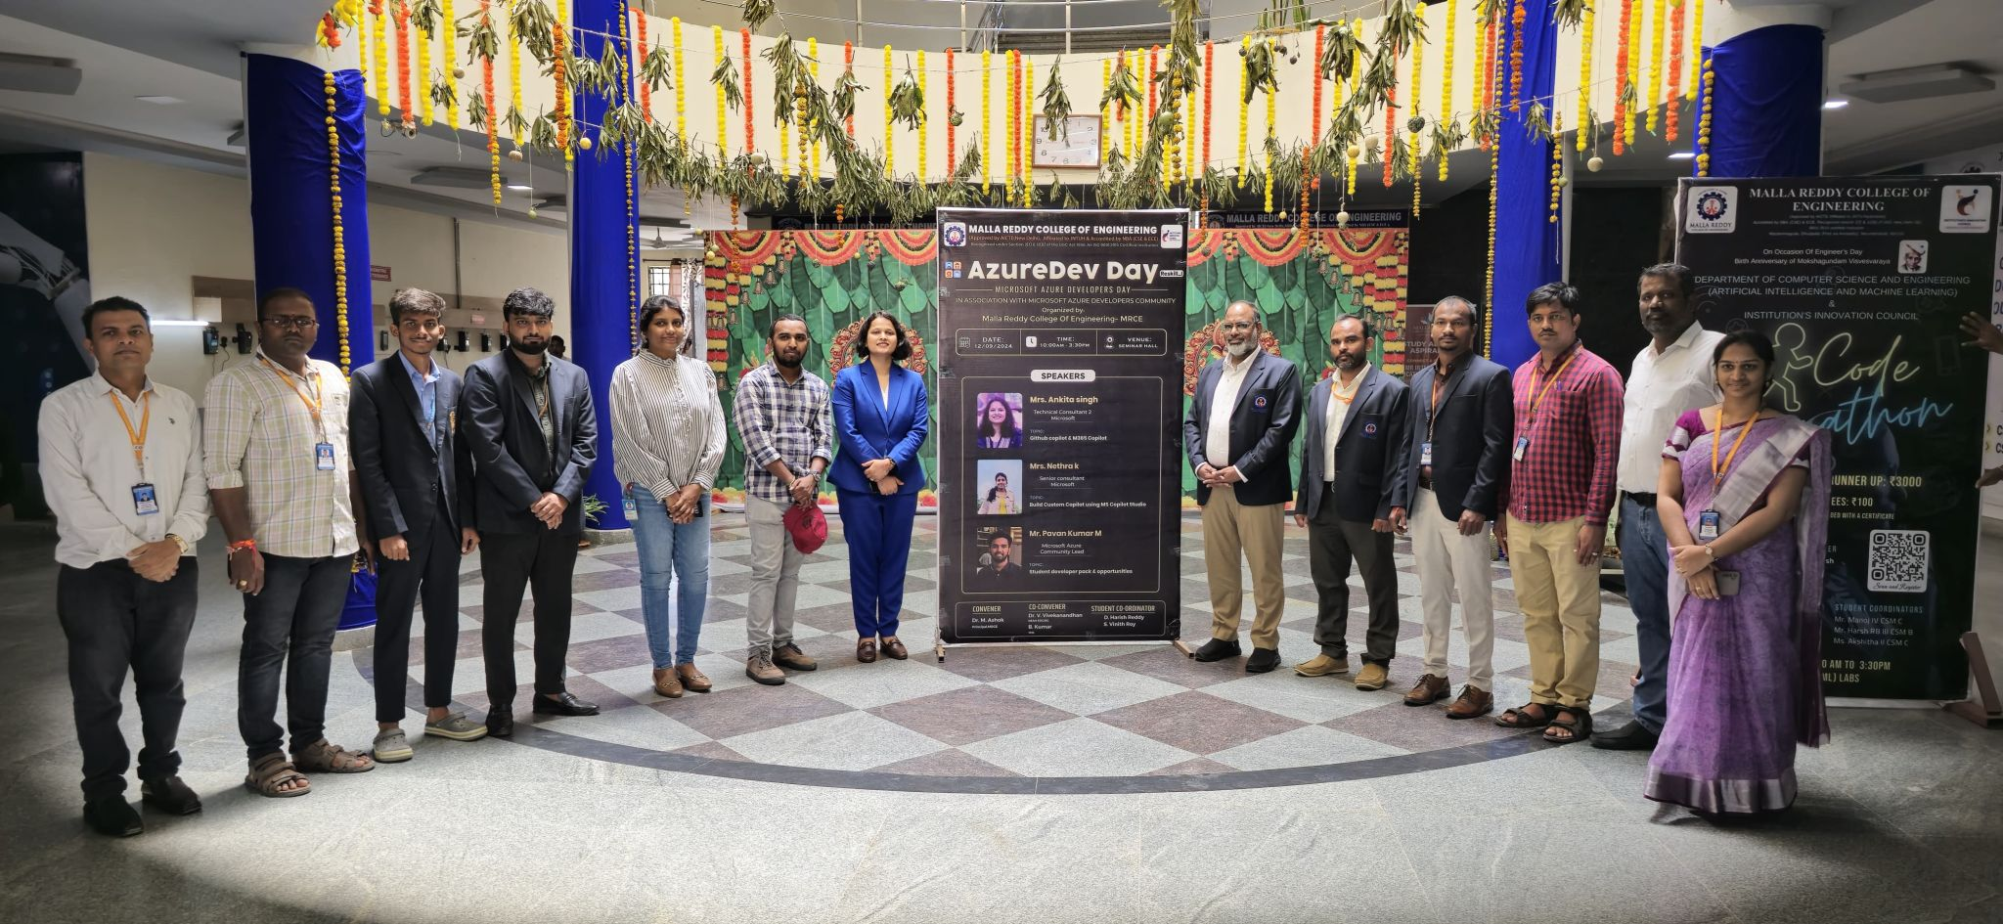My Contribution: Facilitated sessions, shared insights on developer resources, collaborated with faculty and placement officers to ensure student engagement

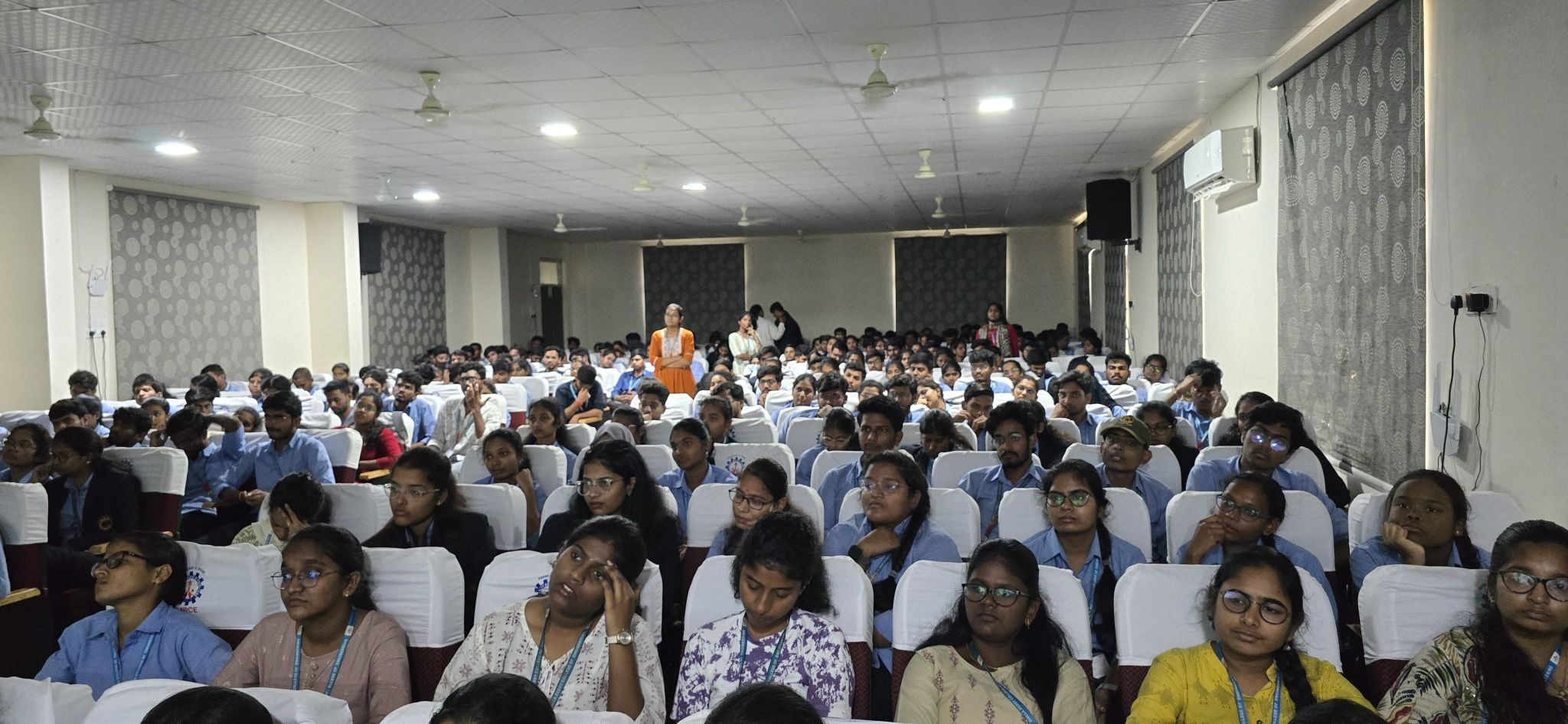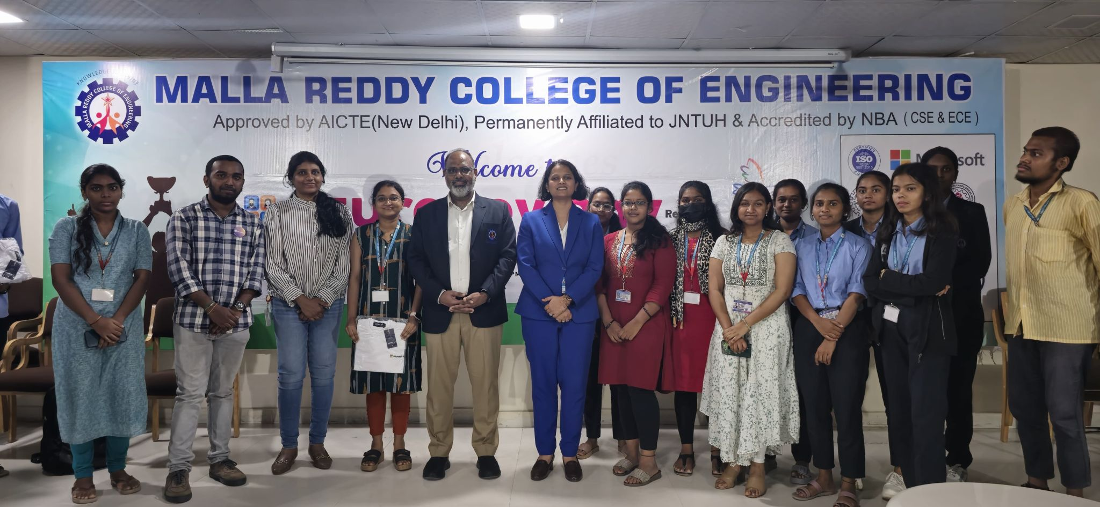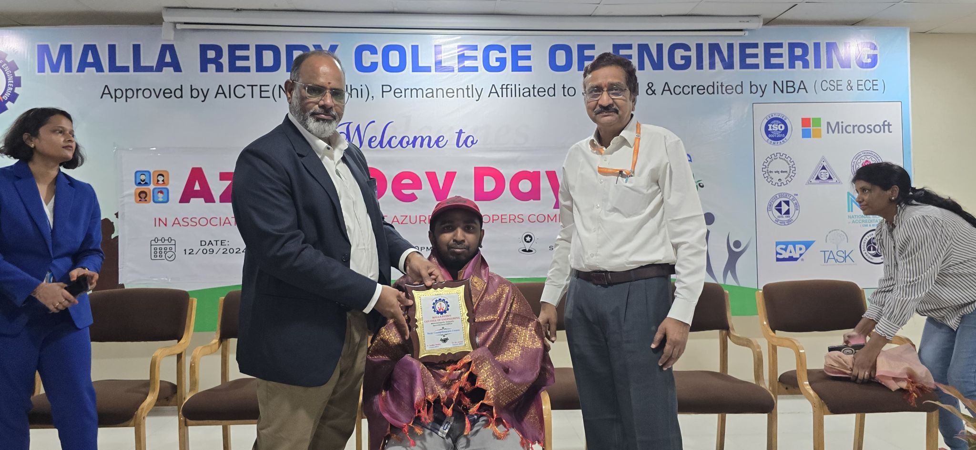

**Impact**

* Enabled students to gain **hands-on experience with Azure AI**.
* Strengthened collaboration between **Microsoft, Reskilll, and Malla Reddy College**.
* Motivated participants to engage with the **Azure Developer Community** for long-term learning.
* Reinforced my role as a **community speaker and mentor** in student-focused events.

**Event / Training Highlight – 15**

📅 **Date:** September 2024  
📍 **Location:** Andhra Engineering College, Nellore (Andhra Pradesh)  
🏢 **Organizer/Partner:** Microsoft | Reskilll | Azure Developer Community  
🎤 **Role:** Community Speaker & Coordinator

**Event Name**

*Azure Developer Day – Andhra Engineering College (Nellore)*

**Description**

I had the privilege of being part of **Azure Developer Day** at Andhra Engineering College, Nellore, where students and faculty explored **AI and cloud technologies** through interactive sessions.

The event featured expert Microsoft speakers:

* **Sanjana Yadav** – Program Manager, Microsoft
* **Jayesh kumar Mevada** – Consultant II, Microsoft

I also had the opportunity to share my own thoughts with the audience, motivating students to **embrace Azure, AI-driven innovation, and community-driven learning**.

* Audience: 150+ students and faculty
* Key Themes: Artificial Intelligence, Azure cloud services, professional growth, student developer resources
* My Contribution: Co-hosted and spoke during the event, engaged participants in Q&A, and coordinated with community members and faculty to ensure smooth execution

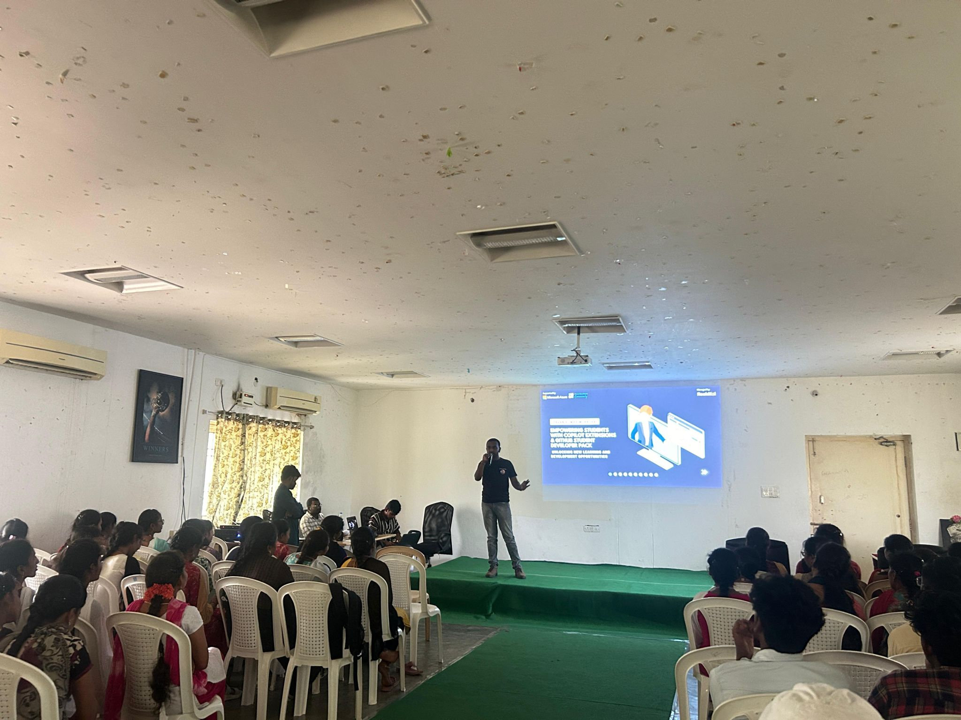

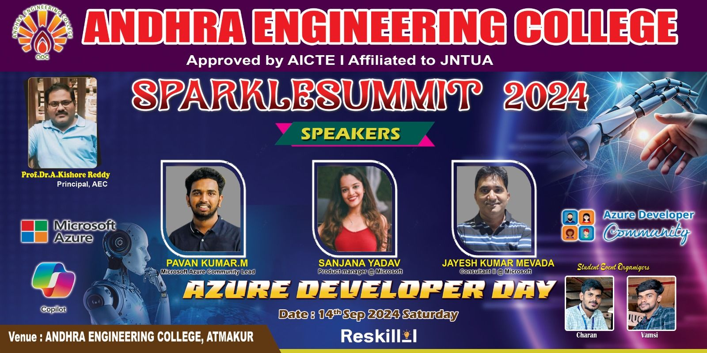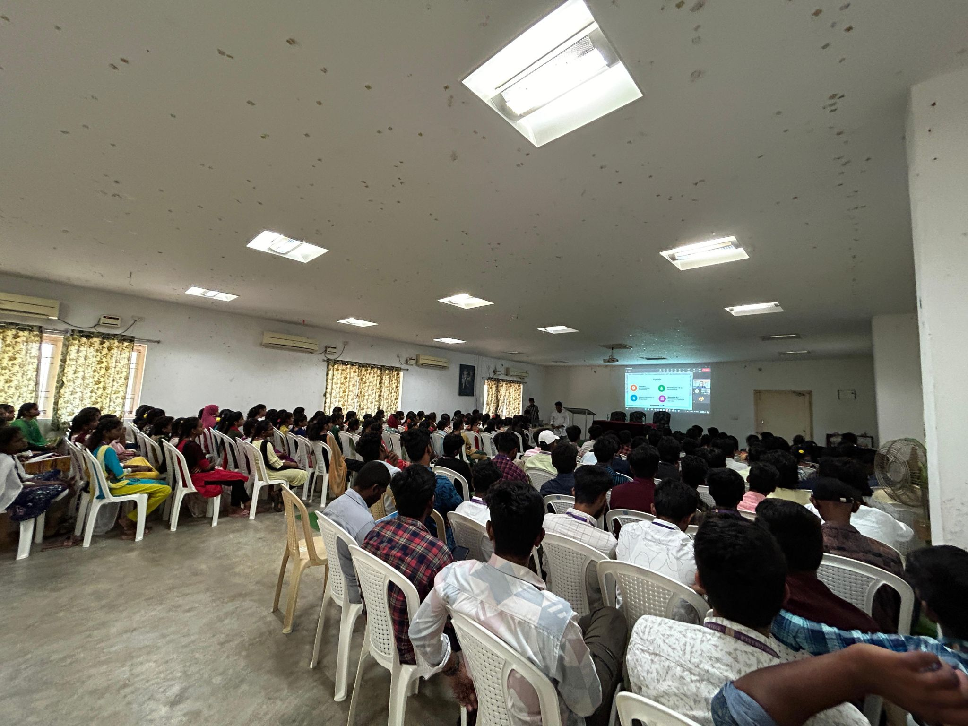

**Impact**

* Helped students gain exposure to **Microsoft Azure AI and cloud technologies**.
* Encouraged participants to pursue **career pathways in cloud and AI**.
* Strengthened collaboration between **Microsoft, Reskilll, and Andhra Engineering College**.
* Reinforced my role as a **community speaker and technical mentor**.

**Event / Training Highlight – 16**

📅 **Date:** 5th October 2024  
📍 **Location:** Microsoft Office, Hyderabad  
🏢 **Organizer/Partner:** Microsoft | Reskilll | Azure Developer Community  
🎤 **Role:** Community Lead & Coordinator

**Event Name**

*Azure AI & Developer Day – Microsoft Hyderabad*

**Description**

I had the privilege of leading and coordinating **Azure AI & Developer Day** at the Microsoft Office, Hyderabad. The event showcased the power of **Generative AI, Azure AI Studio, and M365 Copilot**, enabling participants to explore practical use cases of Microsoft’s AI ecosystem.

The event featured two impactful sessions:

* **Shalina Nandiwada** – *Technical Delivery Manager, Microsoft*  
  *Topic: M365 Copilot and its productivity benefits*
* **Asad Sayeed** – *Founder, Flavor Vista AI*  
  *Topic: Azure AI Studio and building custom Copilot solutions*

Special thanks to **Rohit Sardana** and **Azkar Uddin Khan**, along with my colleagues at **Reskilll and the Azure Developer Community**, for their strong support in making this event a success.

* Audience: 200+ developers, students, and professionals
* Key Themes: Generative AI, M365 Copilot, Azure AI Studio, building custom copilots
* My Contribution: Coordinated event execution, managed speaker sessions, engaged participants, and ensured smooth collaboration between Microsoft, Reskilll, and ADC

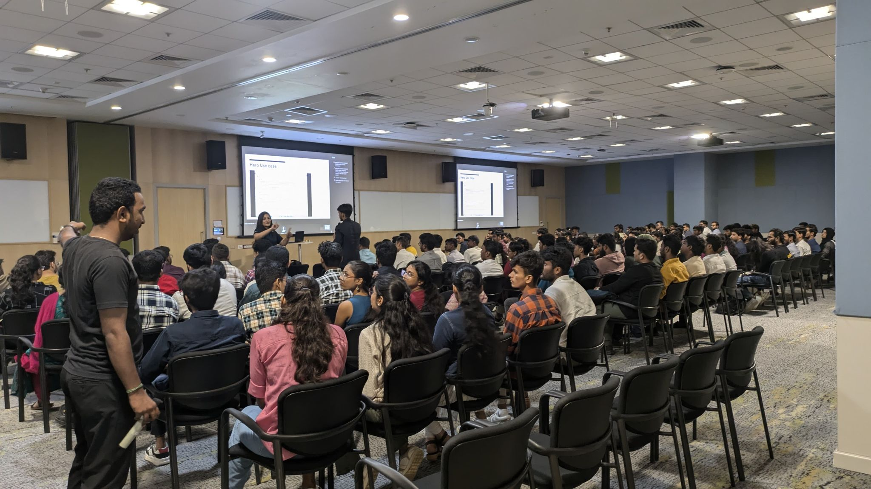

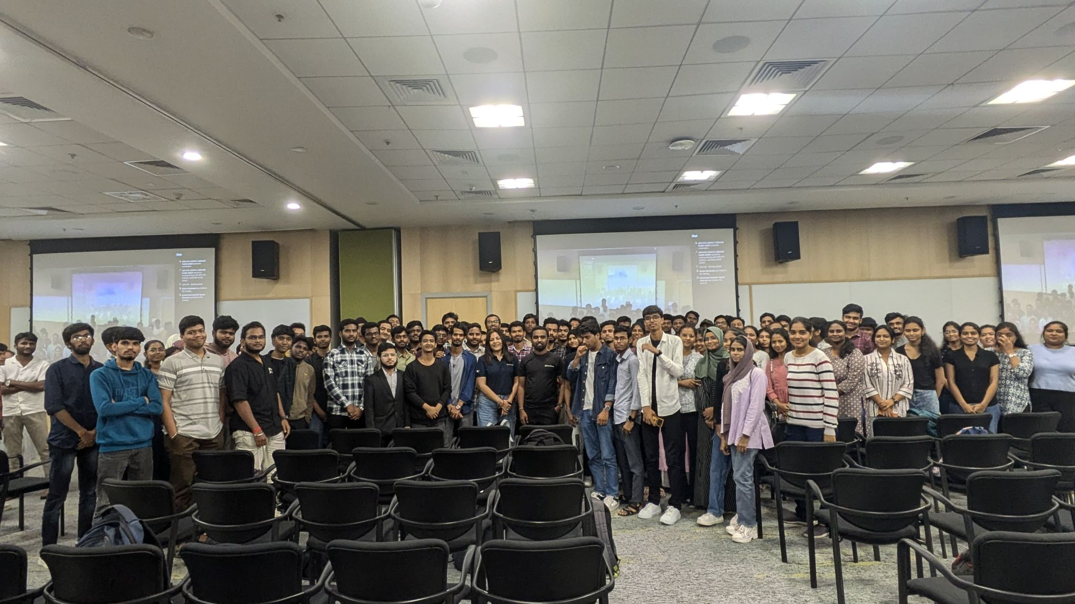

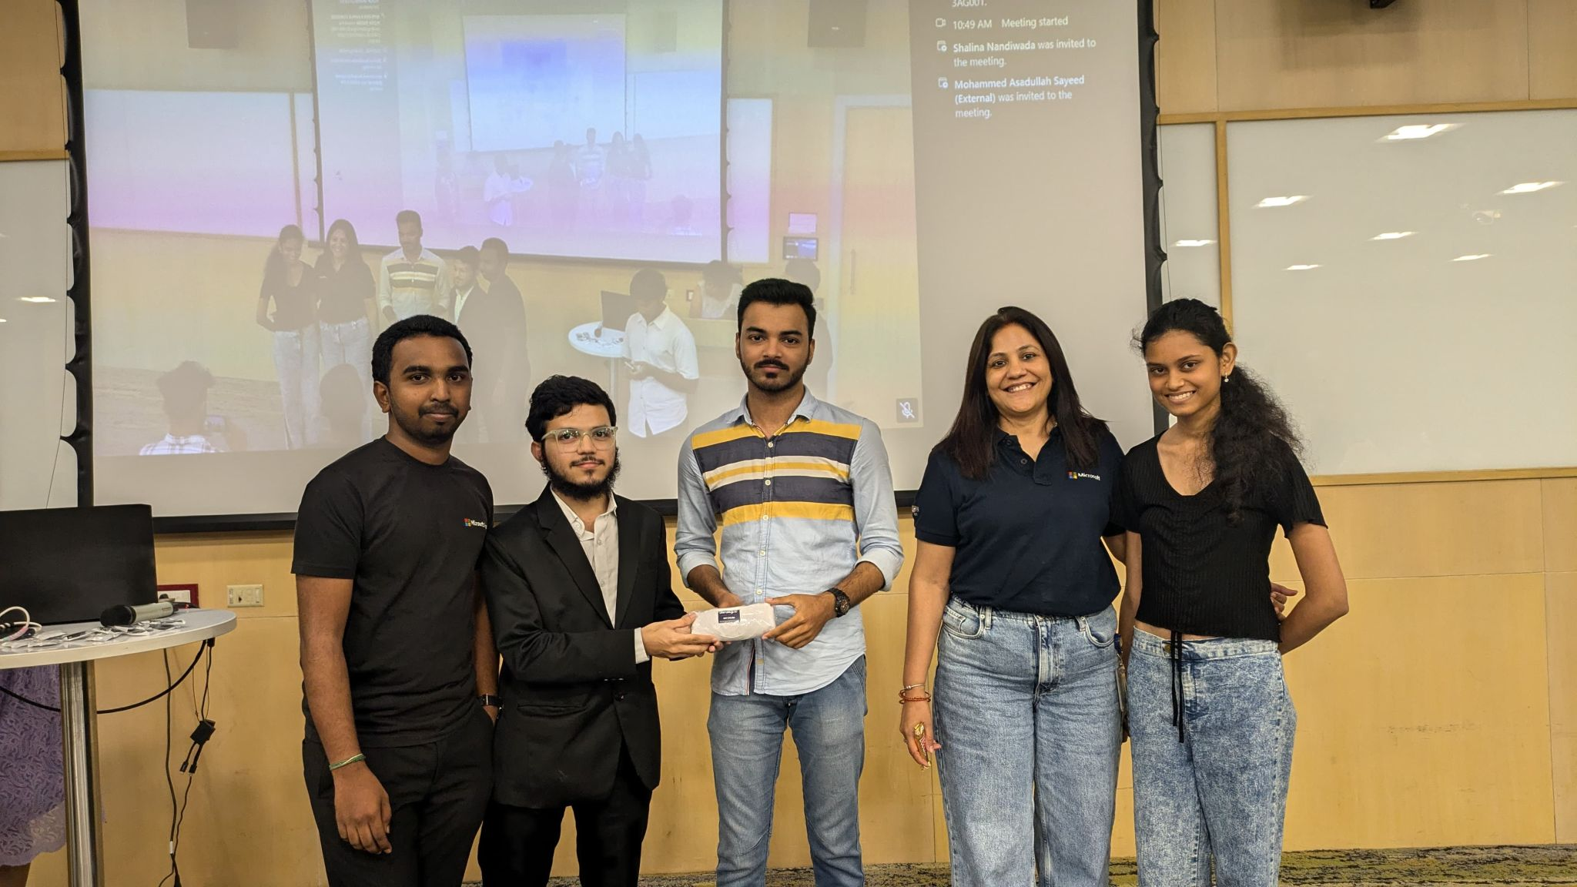

**Impact**

* Introduced developers and students to **Generative AI and Copilot innovation**.
* Strengthened ties between **Microsoft, startup founders, and the developer community**.
* Empowered participants with **practical skills in building AI copilots**.
* Reinforced my leadership as a **Community Lead for Azure AI-focused events**.

**Event / Training Highlight – 17**

📅 **Date:** 21st February 2025  
📍 **Location:** Gokaraju Rangaraju Institute of Engineering and Technology (GRIET), Hyderabad (organized virtually from UK)  
🏢 **Organizer/Partner:** Microsoft Azure | Reskilll | Azure Developer Community  
🎤 **Role:** Student Representative & Virtual Organizer

**Event Name**

*Azure Developer Day – GRIET Hyderabad*

**Description**

I had the privilege of **organizing Azure Developer Day at GRIET (Hyderabad)** as a **Student Representative**, while coordinating virtually from the UK. This event highlighted the latest innovations in **Azure, AI, and Copilot technologies**, and successfully engaged students, faculty, and cloud professionals.

The event featured expert Microsoft speakers:

* **Nethra K** – Senior Consultant, Microsoft
* **Ankita Singh** – Consultant II, Microsoft
* **Shravya Bandaru** – Consultant, Microsoft

Key highlights included **hands-on Azure sessions, discussions on real-world cloud solutions, and networking opportunities** with tech enthusiasts.

* Audience: 250+ students, faculty, and developers
* Key Themes: Azure AI, Copilots, cloud computing, networking and professional growth
* 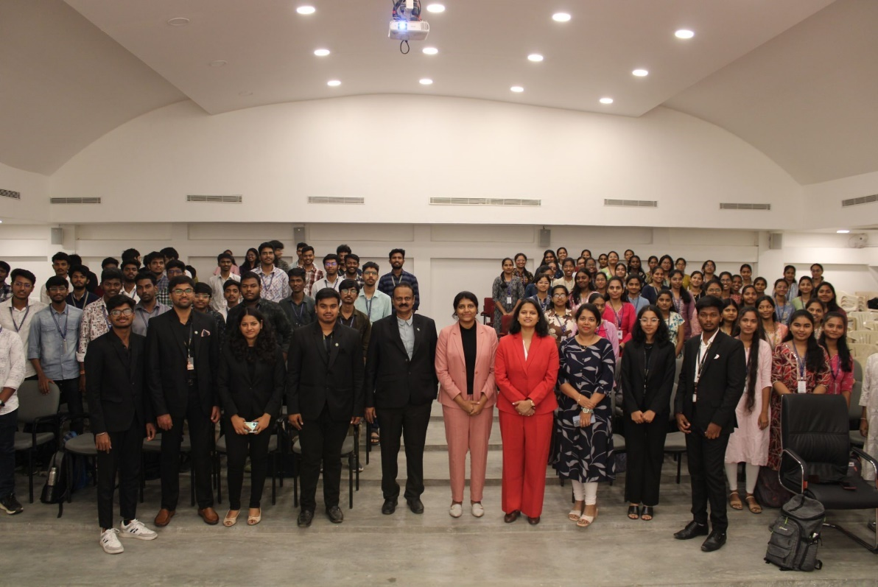My Contribution: Virtually coordinated the event from the UK, managed student engagement through GRIET’s SDC-SB chapter, collaborated with speakers, and represented **Azure Developer Community and Reskilll**

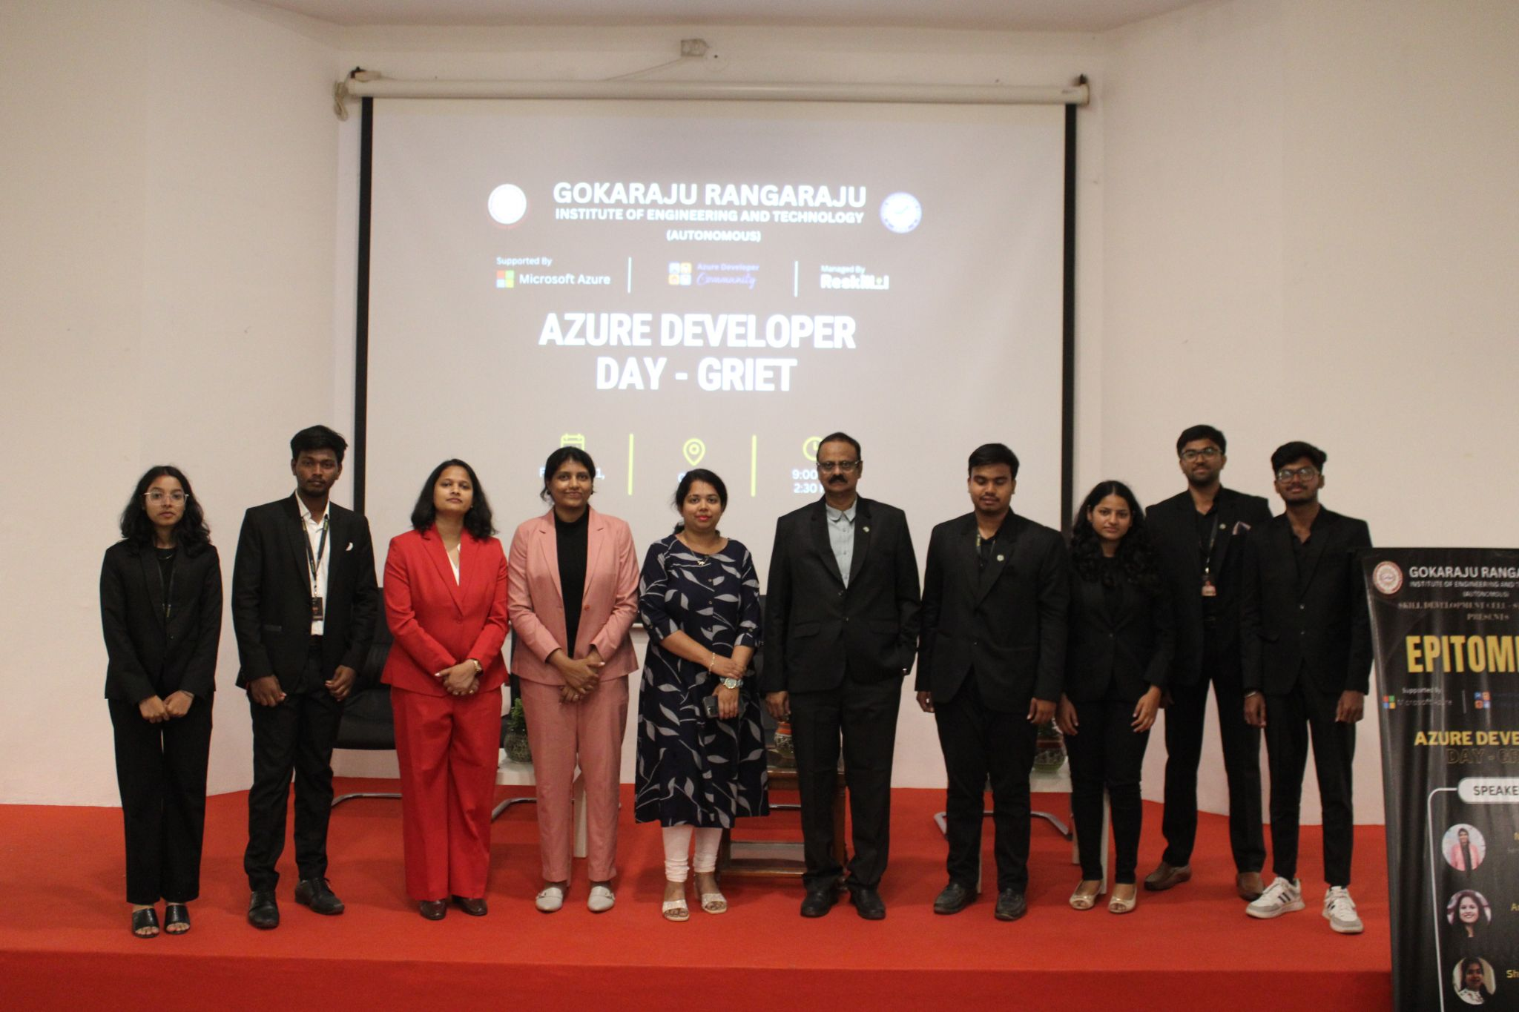

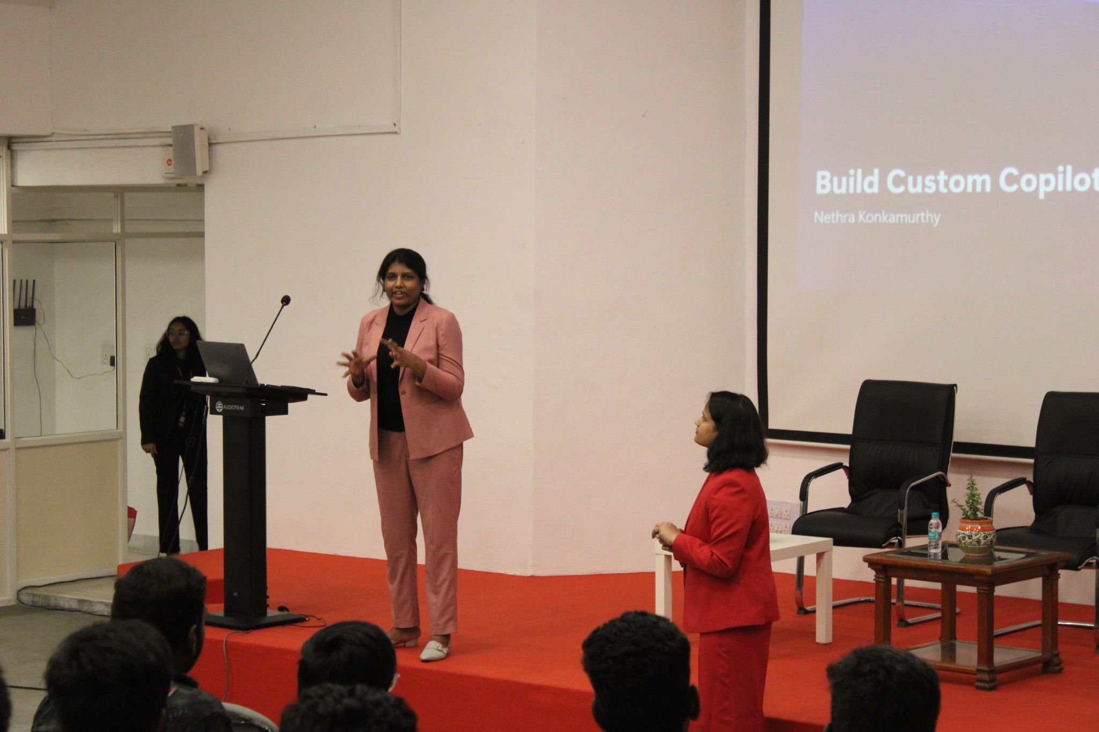

**Impact**

* Showcased my ability to **coordinate international events virtually** while studying in the UK.
* Strengthened ties between **GRIET, Microsoft Azure, Reskilll, and ADC**.
* Empowered students with **hands-on Azure learning and exposure to industry experts**.
* Reinforced my role as a **global student representative and community builder** bridging India and the UK.

**Event / Training Highlight – 18**

📅 **Date:** April 2025  
📍 **Location:** Hyderabad Microsoft Campus  
🏢 **Organizer/Partner:** Microsoft | Reskilll | Azure Developer Community  
🎤 **Role:** Virtual Coordinator & Community Contributor

**Event Name**

*Modernizing Java Applications with AI – Developer Session*

**Description**

I had the opportunity to participate and contribute as a **virtual coordinator** in a **hands-on developer session on modernizing Java applications with AI**. The session explored how **AI-driven features, cloud-native technologies, and Microsoft Azure services** can be leveraged to transform Java applications for **scalability, performance, and innovation**.

The event featured a panel of expert speakers:

* **Deep Amberkar**
* **UmaRani Tejomurtula**
* **Neil D’Cruz**
* **Anshuman Agarwal**
* **Venkat J**

This session engaged developers in **practical demos, architectural discussions, and real-world applications** of AI in Java modernization.

* Audience: Developers and cloud professionals across global regions
* Key Themes: Java app modernization, AI-driven development, Azure cloud-native tools
* 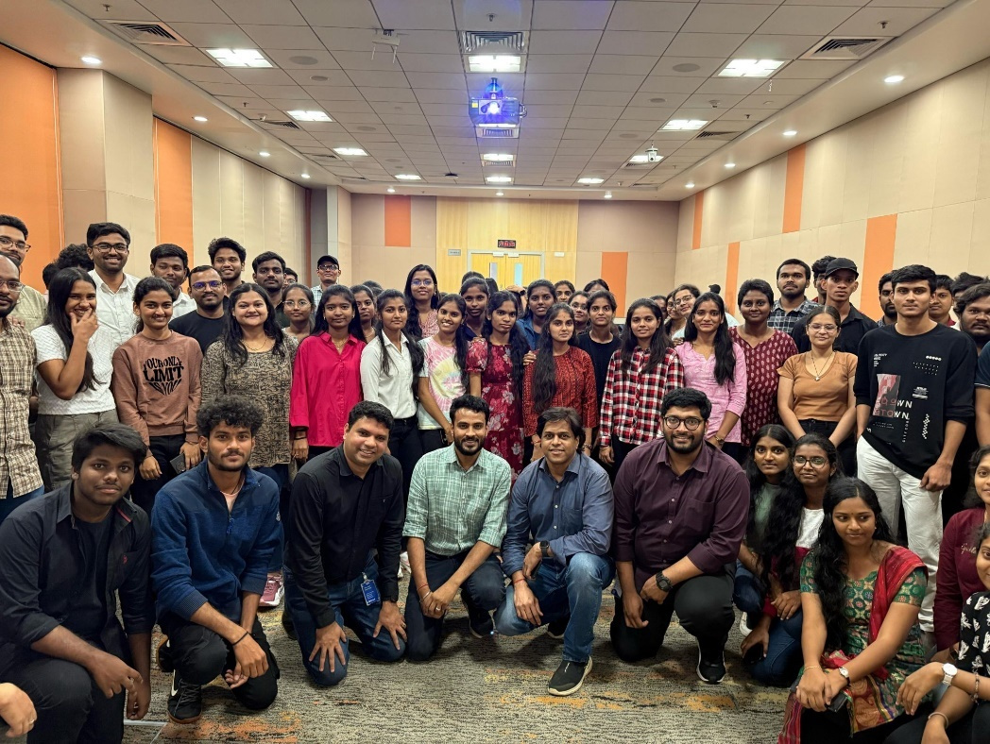My Contribution: Coordinated virtually as part of the Reskilll and Azure Developer Community efforts, supported engagement, and promoted the event globally

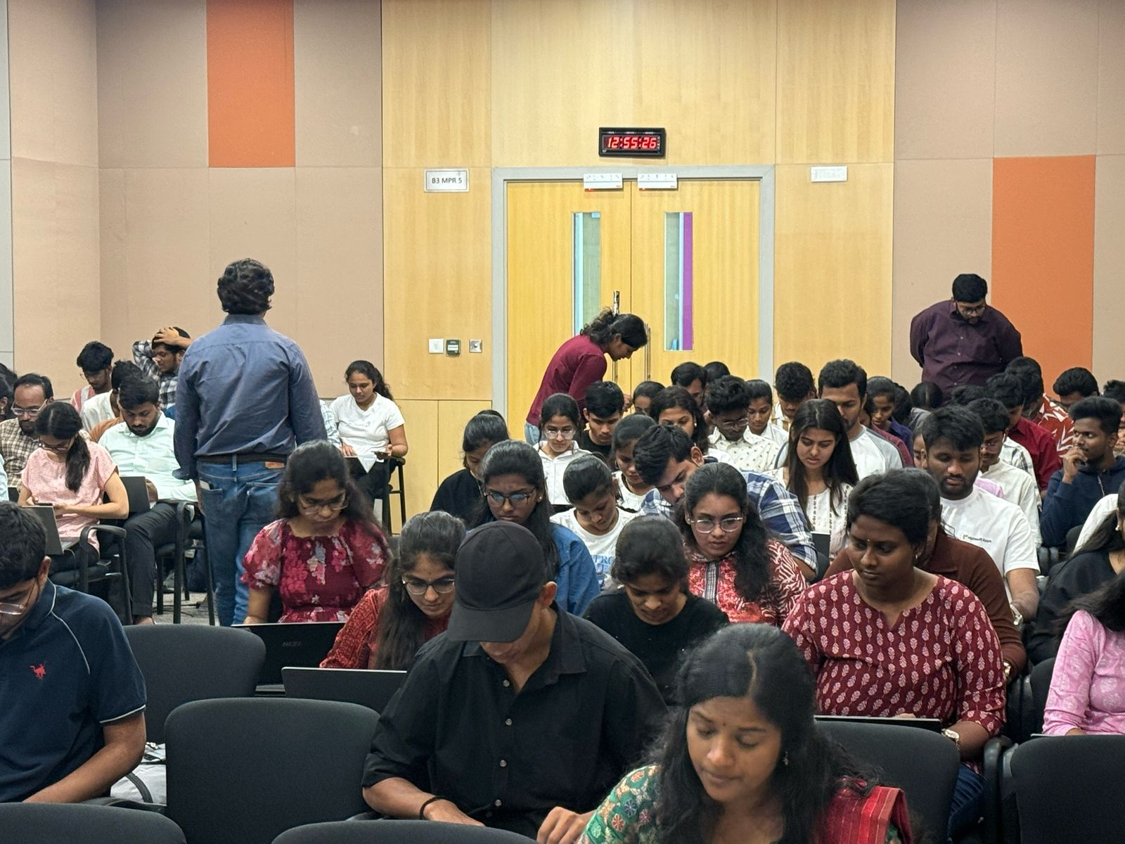

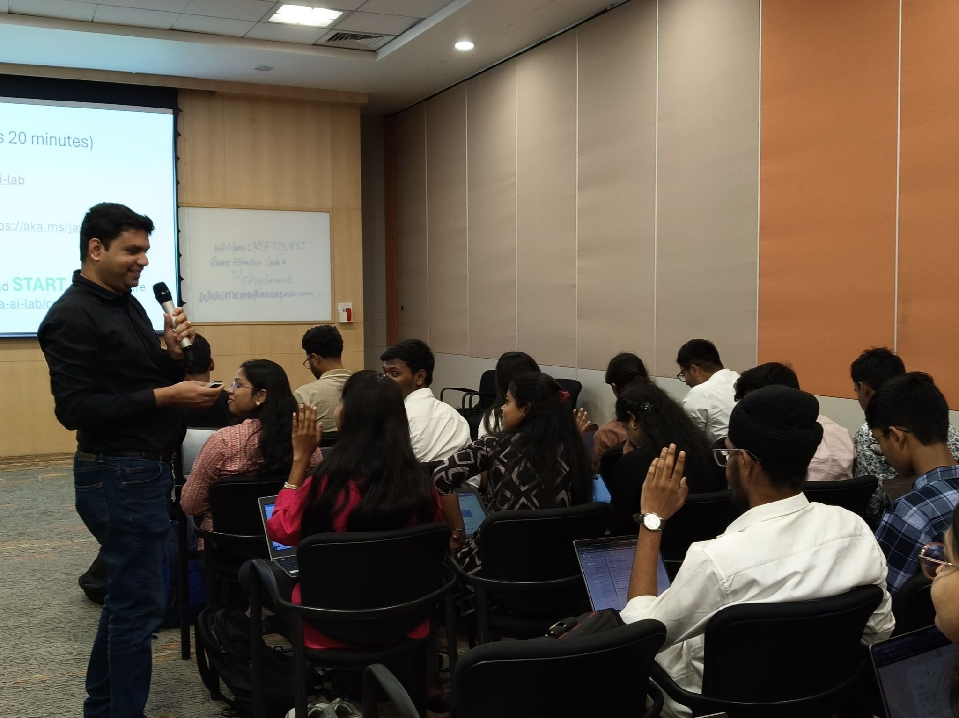

**Impact**

* Strengthened my experience in **AI-driven app modernization** and **Azure services**.
* Enhanced my ability to contribute to **virtual developer events at scale**.
* Supported **global developer learning** on modernizing Java applications with AI.
* Demonstrated my flexibility in leading and contributing to **international events virtually while in the UK**.

**Event / Training Highlight – 19**

📅 **Date:** 04/04/2025  
📍 **Location:** KLH (Hyderabad, India) – Coordinated Virtually from UK  
🏢 **Organizer/Partner:** Microsoft | Reskilll | Azure Developer Community  
🎤 **Role:** Virtual Coordinator & Lead

**Event Name**

*AI Dev Camp – KLH Hyderabad*

**Description**

I had the privilege of serving as the **Virtual Coordinator & Lead** for the **AI Dev Camp at KLH**, where developers, innovators, and students came together to explore the future of **Artificial Intelligence, Machine Learning, and Deep Learning**.

The camp featured expert-led sessions from inspiring speakers:

* **Purushotham Chanda (PC)**
* **Satya Addala**

The event combined **hands-on AI projects, technical training, and collaborative workshops**, enabling participants to build practical solutions and gain real-world insights into the power of AI.

* Audience: 200+ participants (students, developers, and AI enthusiasts)
* Key Themes: AI, ML, DL, Azure AI applications, future-ready developer skills
* 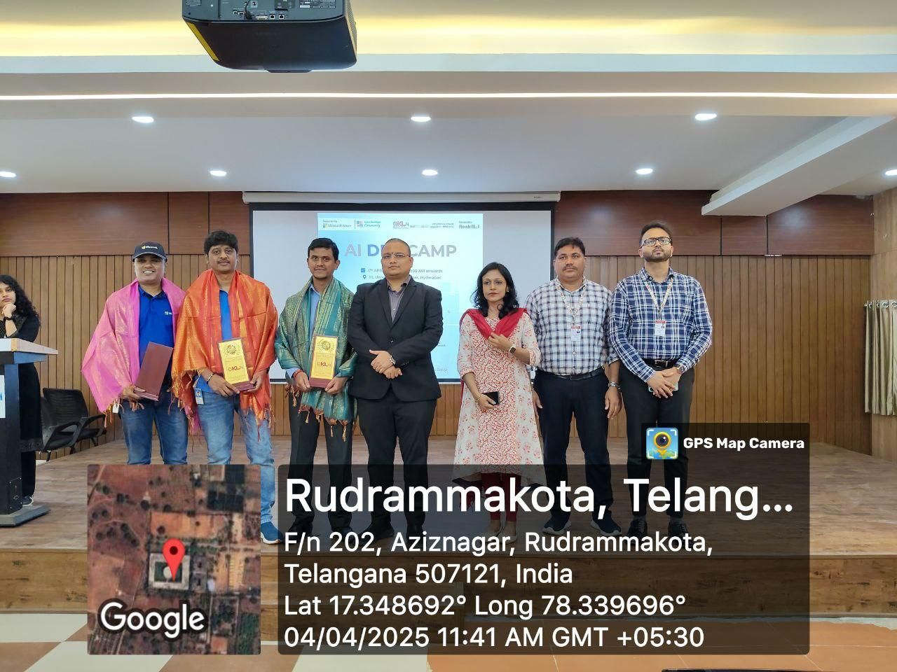My Contribution: Coordinated the event virtually from the UK, managed community engagement, supported speaker sessions, and represented **Reskilll and the Azure Developer Community**

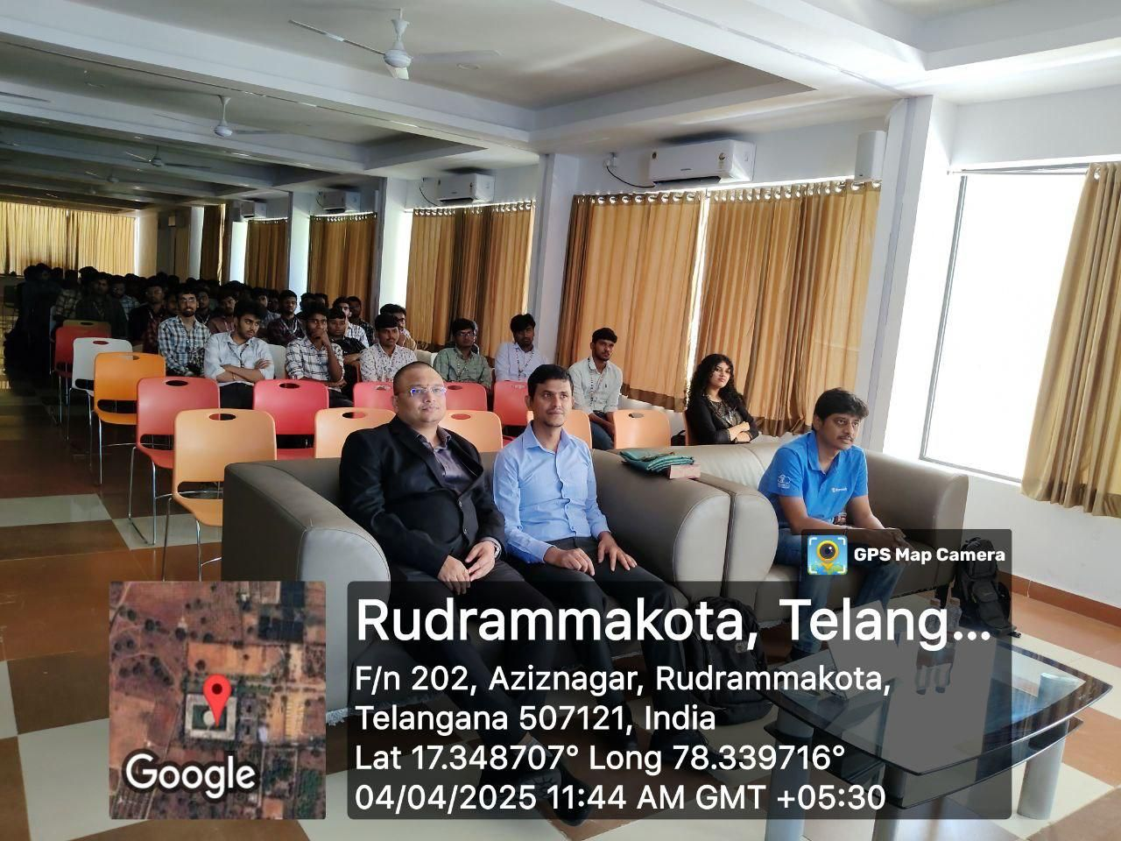

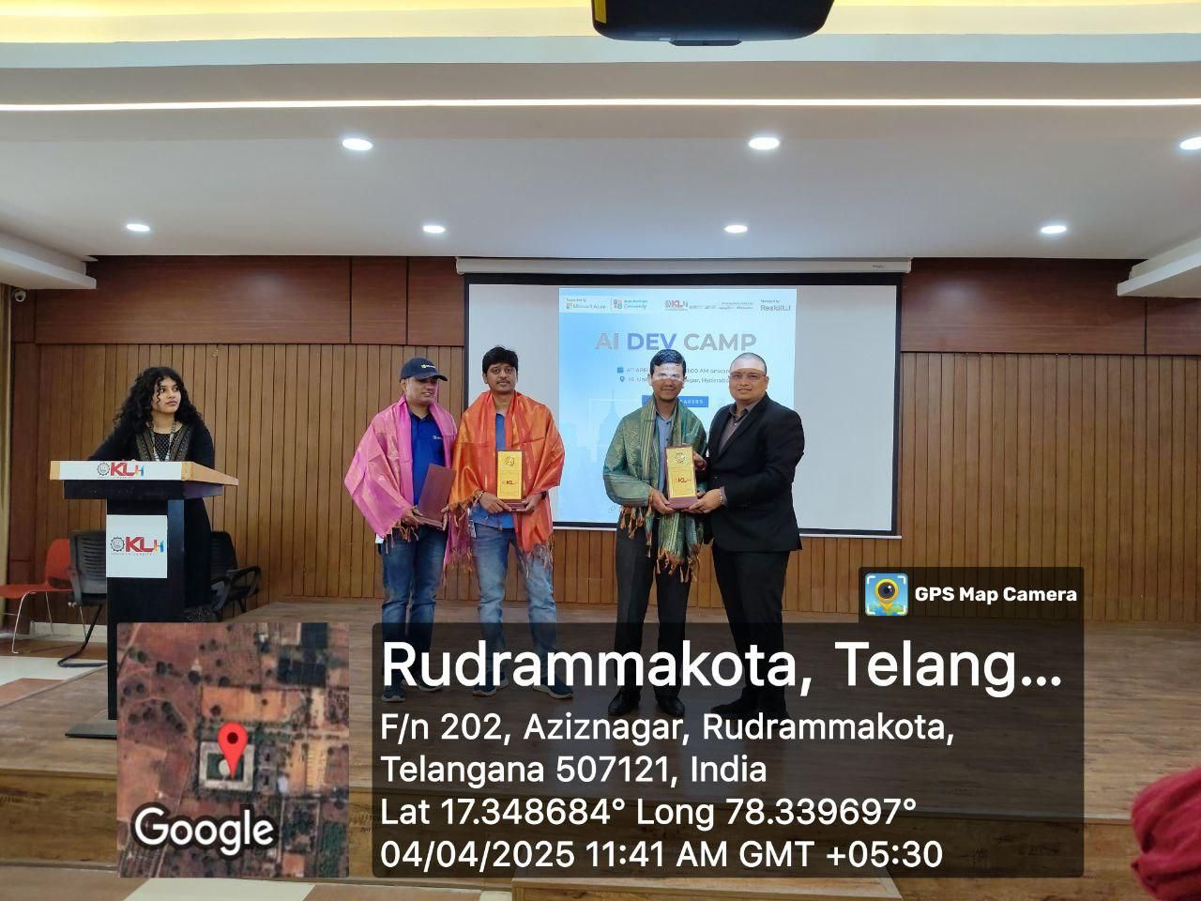

**Impact**

* Strengthened **AI skill development** among students and developers at KLH.
* Showcased my ability to **lead large-scale events virtually across borders**.
* Reinforced collaboration between **Microsoft experts, Reskilll, and the Azure Developer Community**.
* Inspired participants to pursue **AI-driven innovation and career pathways**.

**Event / Training Highlight – 20**

📅 **Date:** 12th April 2025  
📍 **Location:** Online (Global)  
🏢 **Organizer/Partner:** Microsoft | Reskilll | Azure Developer Community  
🎤 **Role:** Virtual Coordinator & Community Lead

**Event Name**

*AI Skills Fest: Fundamentals of Generative AI*

**Description**

I had the privilege of serving as a **Virtual Coordinator & Community Lead** for the **AI Skills Fest: Fundamentals of Generative AI**, a global, free hands-on workshop designed to introduce participants to the **basics of Generative AI**.

The session was led by **Viral Shah, Senior Consultant at Microsoft**, who delivered an insightful training on how **Gen AI works across text, images, and code**, with practical real-world use cases and live demos.

* Audience: 300+ global participants (students, developers, professionals)
* Key Themes: Generative AI fundamentals, practical tools, real-world applications
* My Contribution: Coordinated the event virtually, promoted registrations, engaged participants during the session, and represented **Reskilll and the Azure Developer Community**

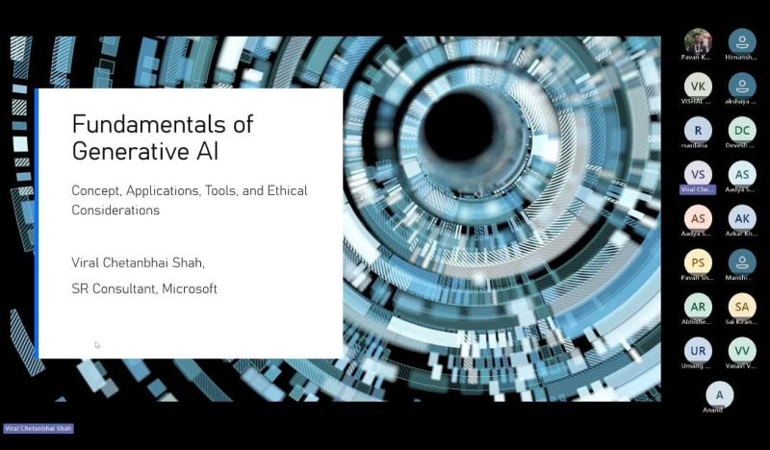

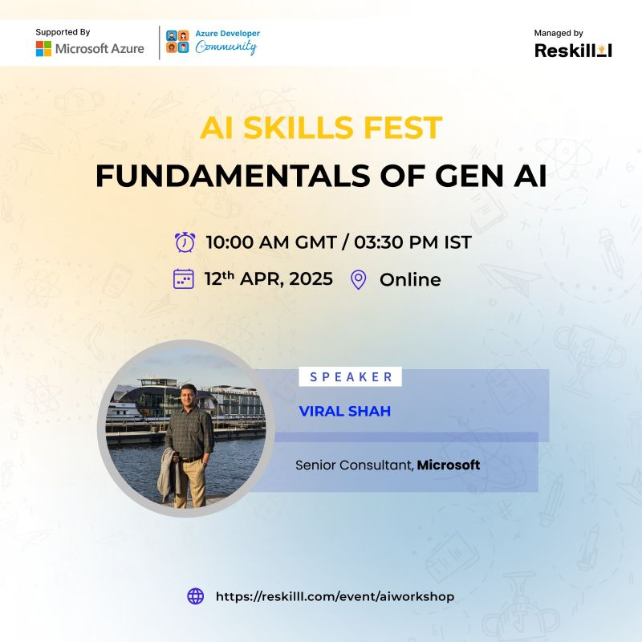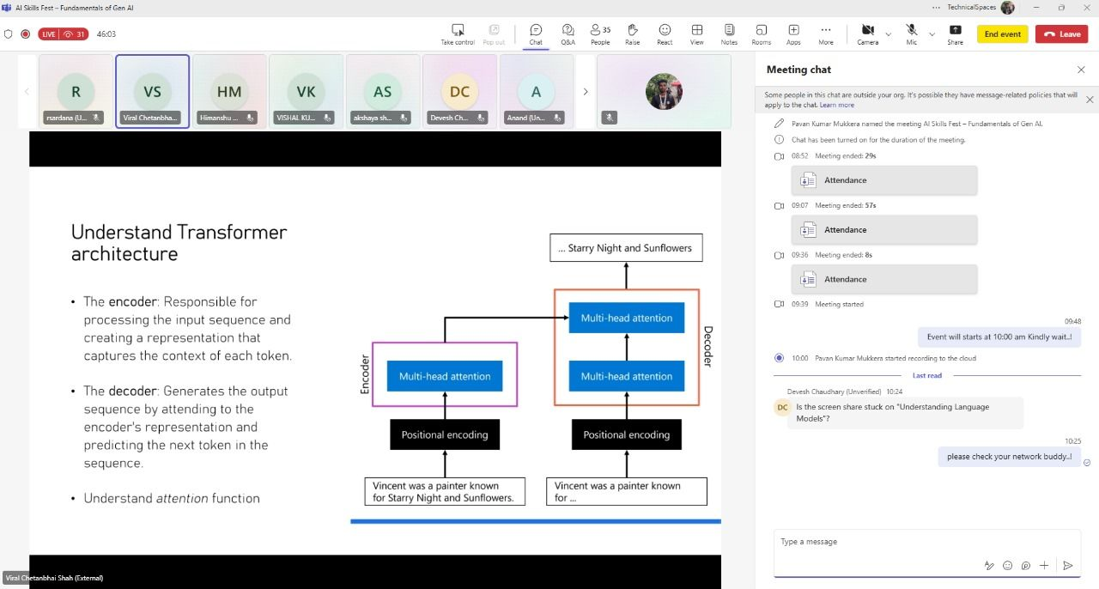

**Impact**

* Introduced **foundational Generative AI concepts** to a global audience.
* Strengthened community collaboration between **Microsoft, Reskilll, and ADC**.
* Empowered participants to confidently begin their **AI learning journey**.
* Showcased my leadership in **organizing global virtual workshops** as a Community Lead.

**vent / Training Highlight – 21**

📅 **Date:** June 2025 (during India trip)  
📍 **Location:** Microsoft Campus, Hyderabad  
🏢 **Organizer/Partner:** Microsoft | Reskilll | Azure Developer Community | Swamy’s Tech Skills Academy | P. R. Pote Patil Group of Educational Institutes  
🎤 **Role:** Speaker, Coordinator & Initiative Presenter

**Event Name**

*GitHub Copilot Event – Microsoft Campus Hyderabad*

**Description**

During my India trip, I had the opportunity to serve as a **speaker and coordinator** at the **GitHub Copilot Event** hosted at Microsoft Campus, Hyderabad. The event combined **technical sessions on GitHub Copilot and AI** with a showcase of my new initiative, **TheYouthTalks**, designed to empower **Gen Z voices** through surveys, hackathons, and internships.

The event featured contributions from:

* **Shalini Singh** – Azure Identity Engineer, Microsoft
* **Viswanatha Swamy** – Microsoft MVP, along with the **Swamy’s Tech Skills Academy team** (Sahithi, Joshitha, Nidhi, Hemanth, Yashasri, Gayathri, Manish, Amit, Sai Vamshi)

With the support of **Rohit Sardana**, **Azkar Uddin Khan**, and dedicated volunteers **Deekshith Bondhugula** and **Karthikeya Reddy**, the event successfully combined **community engagement, surveys, and hands-on Copilot learning**.

A special recognition came from **P. R. Pote Patil Group of Educational Institutes, Amravati**, who felicitated me for my community contributions, an honor that reinforced my passion for **tech-driven youth empowerment**.

* Audience: 200+ developers, students, and community members
* Key Themes: GitHub Copilot, AI-driven developer productivity, youth empowerment through TheYouthTalks
* 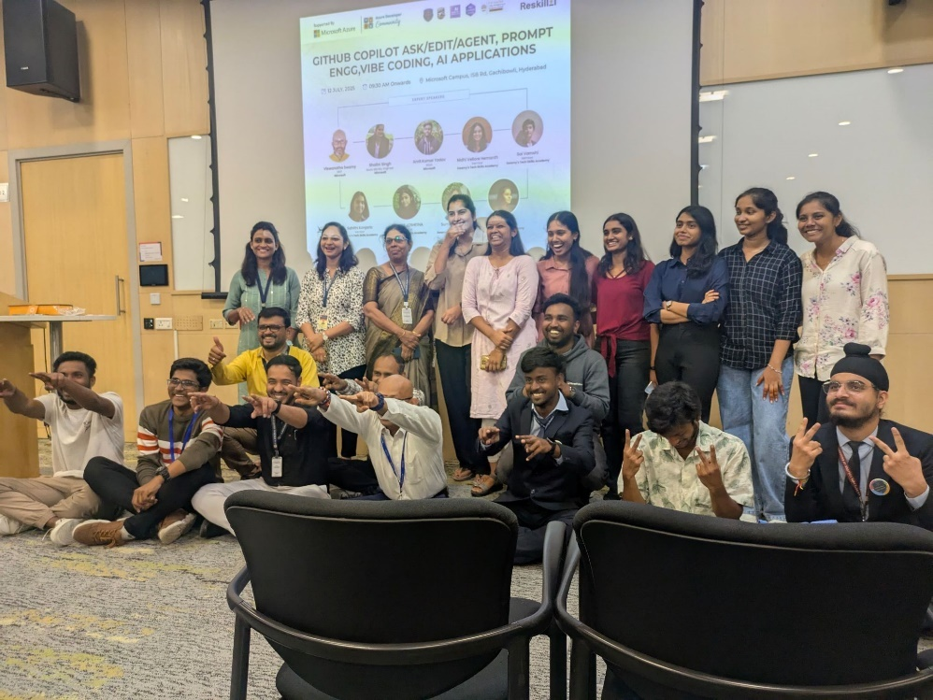My Contribution: Coordinated event activities, delivered a presentation, introduced TheYouthTalks initiative, facilitated surveys and hackathon outreach

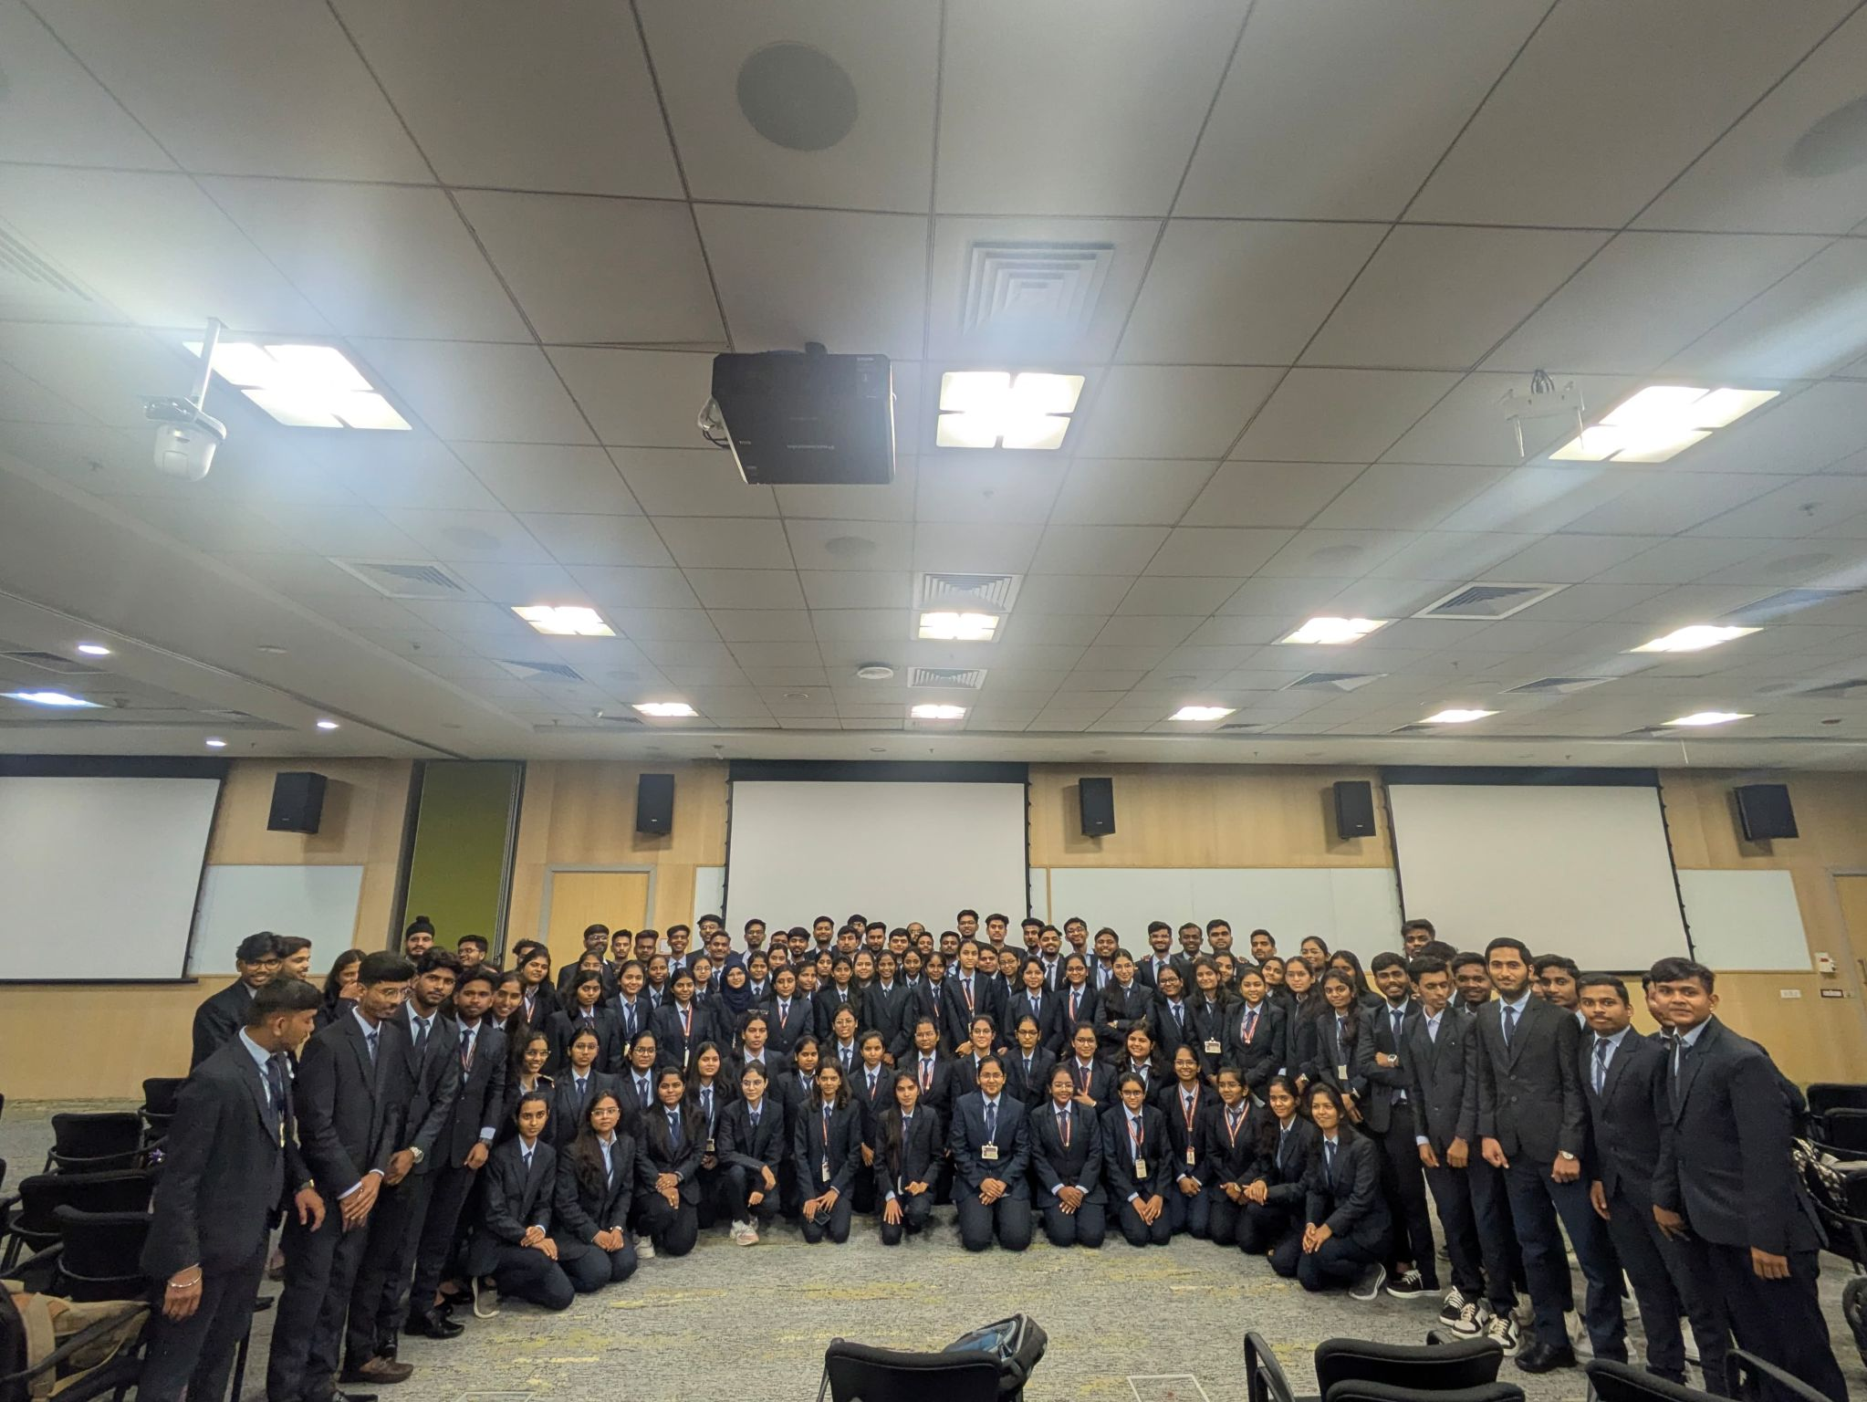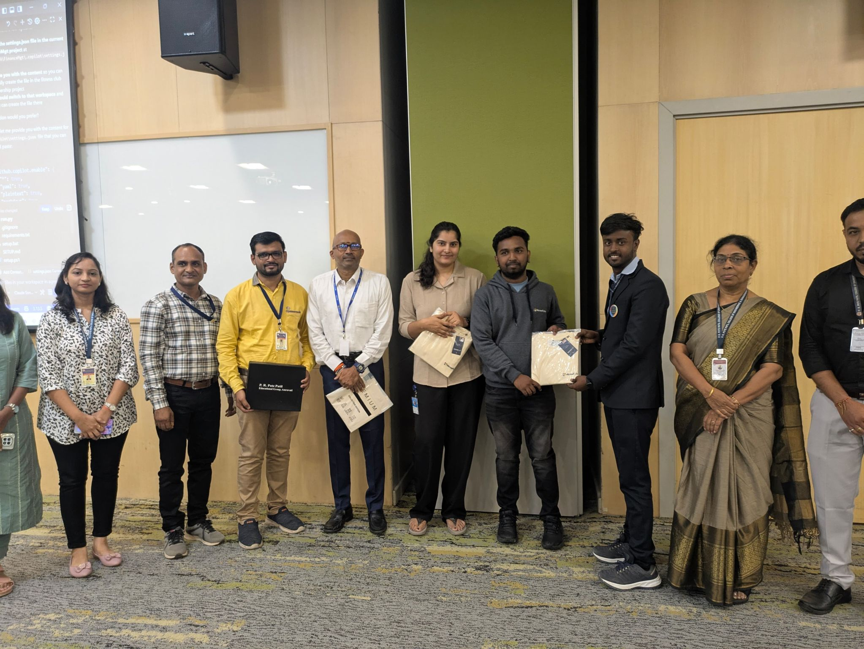

**Impact**

* Showcased **GitHub Copilot and AI tools** to a diverse developer community.
* Launched and promoted **TheYouthTalks initiative**, engaging Gen Z in innovation.
* Recognized with **felicitation for contributions to community building**.
* Strengthened collaboration between **Microsoft, Reskilll, ADC, and educational institutions**.

**🌍 100+ Events | 20,000+ Learners | India → UK → Global**

Over the last few years, I have had the privilege of:

* ✅ **Organizing & Leading 100+ events** across India, UK, and global virtual platforms.
* ✅ Reaching **20,000+ students, developers, and professionals** through workshops, hackathons, and training days.
* ✅ Collaborating with **Microsoft, Reskilll, Azure Developer Community, universities, and startups**.
* ✅ Building strong **technical communities** around **Azure, AI, DevOps, GitHub Copilot, and Cloud Computing**.
* ✅ Driving **cross-border impact**, leading events virtually from the UK while empowering communities in India.

**🔑 Key Focus Areas**

* Community Leadership & Event Management
* Technical Training & Hands-On Learning
* Azure AI, GitHub Copilot, Cloud & DevOps
* Student Engagement & Professional Development
* Cross-Border Collaboration (India–UK–Virtual Global)

**📩 Let’s Connect & Collaborate**

**Mukkera Pavan Kumar**  
📧 Email: **Mukkera474@gmail.com**  
📱 Phone: **+44 7887132357**  
🔗 LinkedIn: [Pavan Kumar Mukkera | LinkedIn](https://www.linkedin.com/in/pavankumarmukkera/)  
💻 GitHub/Portfolio: [pavankumarmukkera (PAVAN KUMAR MUKKERA)](https://github.com/pavankumarmukkera)